Chapter 1: Introduction to Linux and Ubuntu
whoami
Shows the name of the user who is logged in.

pwd
Shows the folder you are in now.

ls
Shows the files and folders in the current folder.
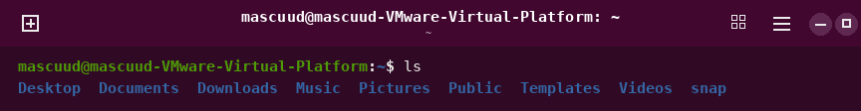
cat /etc/os-release
Shows the text inside a file. This file tells the Linux name and version.
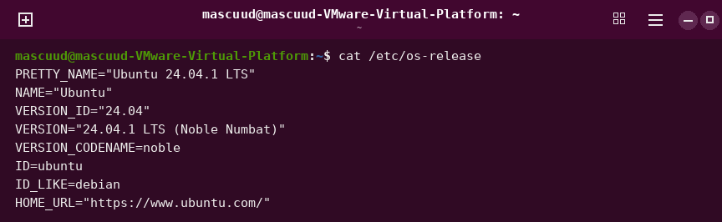
uname -r
Shows the version number of the Linux kernel.
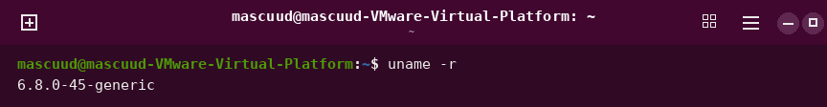
uname -s
Shows the name of the operating system.
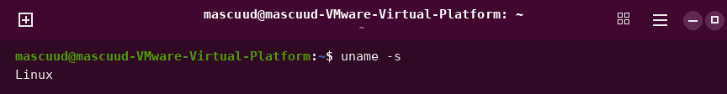

Chapter 2: Linux System Architecture and Management
echo $SHELL
Shows the name of your shell program.
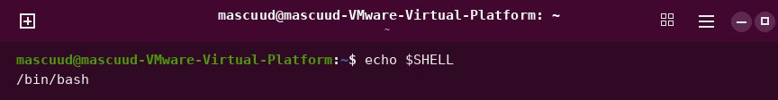
history
Shows the commands that were used before in the terminal.
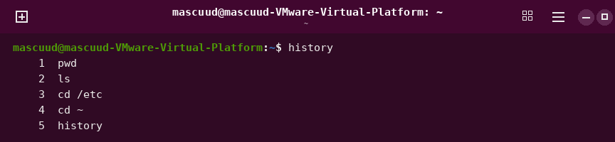
mkdir --help
Shows a short help text for the mkdir command.
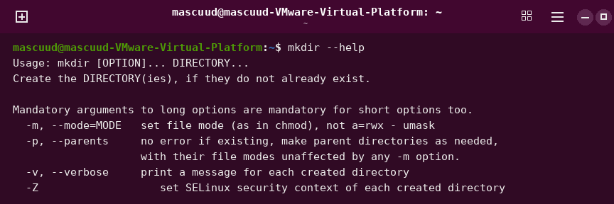
man grep
Opens the full manual of the grep command. Press q to quit.
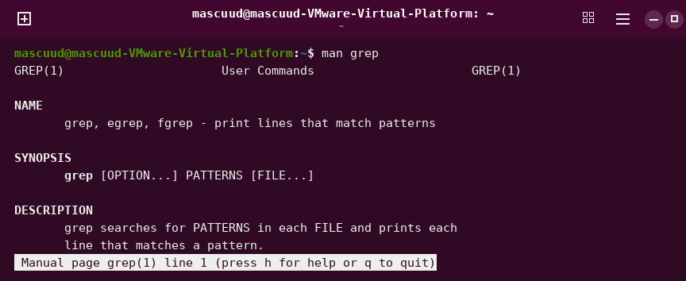
man cd
Shows that cd has no manual page, because it is built into Bash.
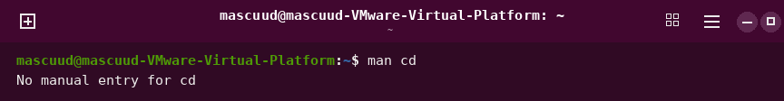
help cd
Shows help for the cd command.
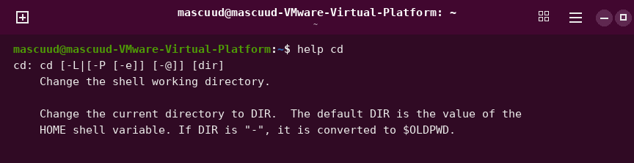
info ls
Opens a longer guide for the ls command. Press q to quit.
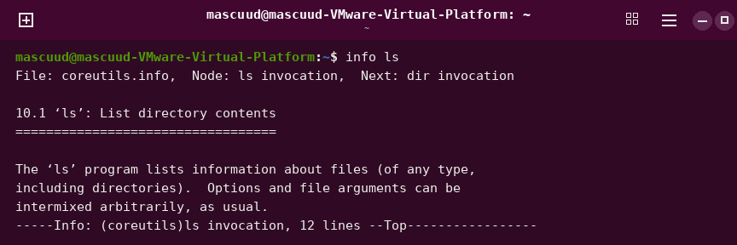
echo Hello $USER
Prints the words. Bash joins the spaces and puts in your user name.
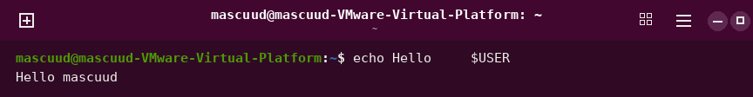
echo "Hello $USER"
Prints the words and keeps the spaces. Your user name is still put in.
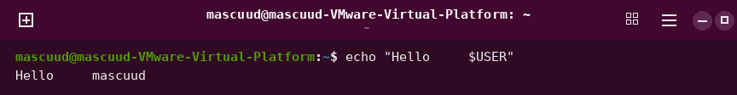
echo 'Hello $USER'
Prints the words exactly as you typed them. Nothing is changed.
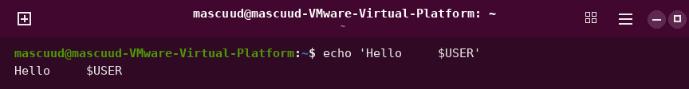
touch new file
Makes two files, called new and file, because of the space.
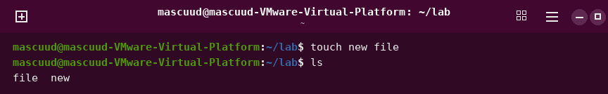
touch "new file"
Makes one file called "new file". The quotes keep the space.
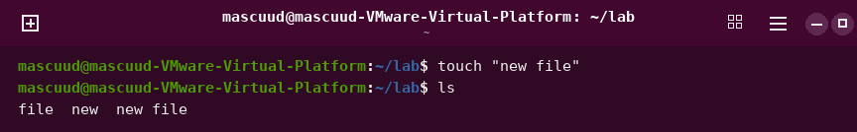
echo \$HOME
Prints $HOME as text. The backslash stops its special meaning.

ls *.txt
Lists all files that end with .txt. The star means any letters.
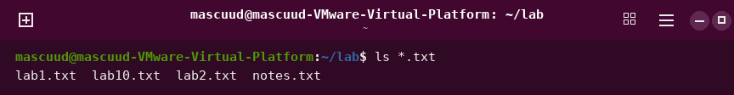
ls lab?.txt
Lists files that have exactly one letter where the ? is.
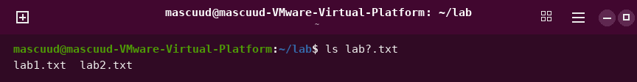
ls lab[12].txt
Lists files that have 1 or 2 where the brackets are.
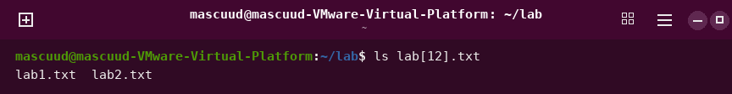
ls *[0-9].jpg
Lists .jpg files that end with one number before .jpg.
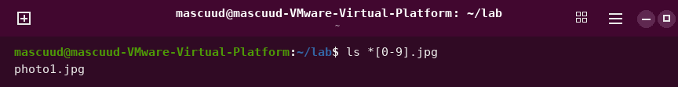
COURSE=linux
Makes a variable called COURSE with the value linux.

echo $COURSE
Shows the value of the variable COURSE.
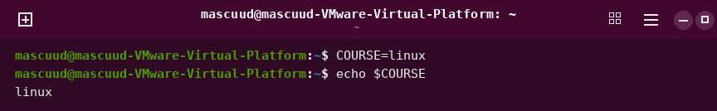
COURSE = linux
Does not work. Spaces around = give an error.
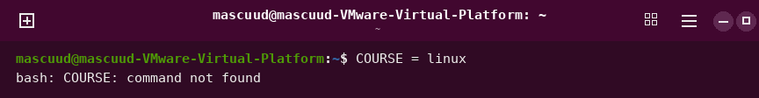
export COURSE
Shares the variable with other programs.
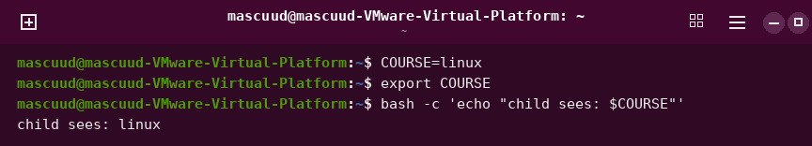
echo $HOME $USER
Shows your home folder and your user name.

echo $PATH
Shows the list of folders where Bash looks for commands.
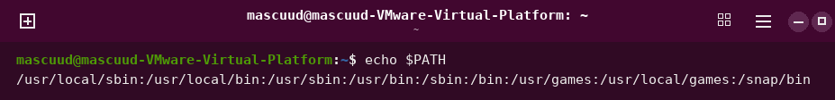
ls /usr/bin/ls
Shows the file of the ls command in /usr/bin.
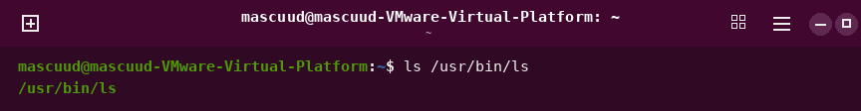
pwd
Shows the folder you are in now.
cd /var/log
Goes to the /var/log folder.
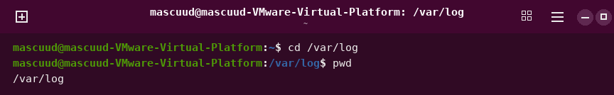
cd ..
Goes up to the parent folder.
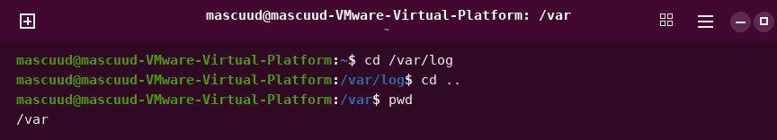
cd -
Goes back to the last folder you were in.
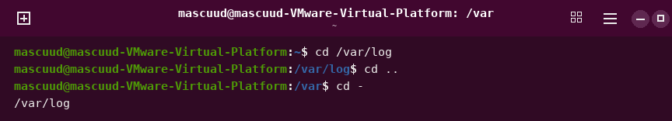
cd (alone) and cd ~
Goes to your home folder.
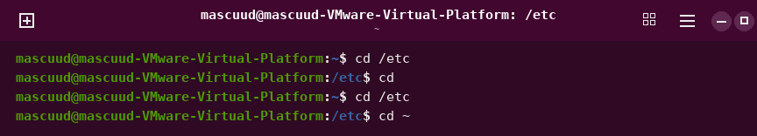
cd /etc
Goes to the /etc folder.
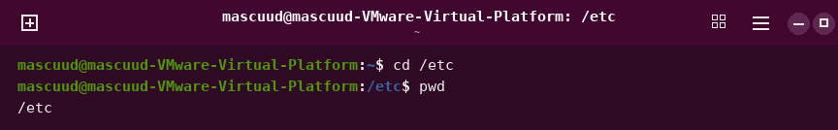
cd ~/Documents
Goes to the Documents folder inside your home.
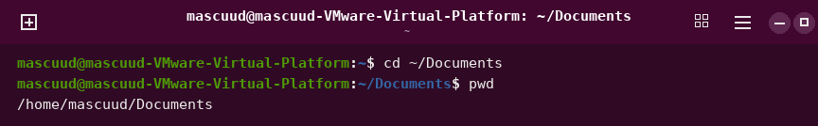
cd ../..
Goes up two folders.
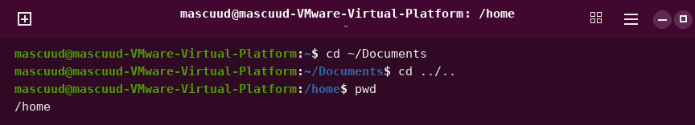
cd .
Stays in the same folder.
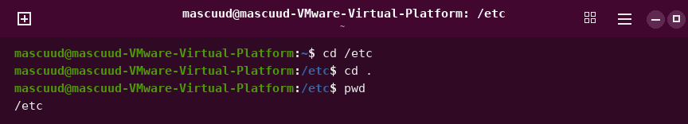
ls
Lists the files and folders here.
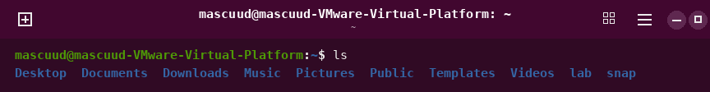
ls /
Lists the files and folders in the top folder.
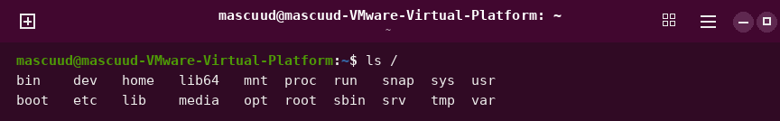
ls -a / ls --all
Shows hidden files too. Hidden names start with a dot.
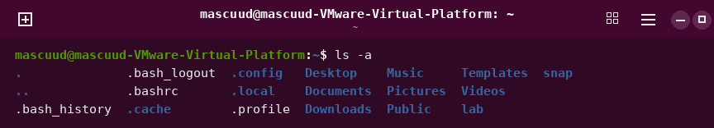
ls -l
Shows a long list with details about each file.
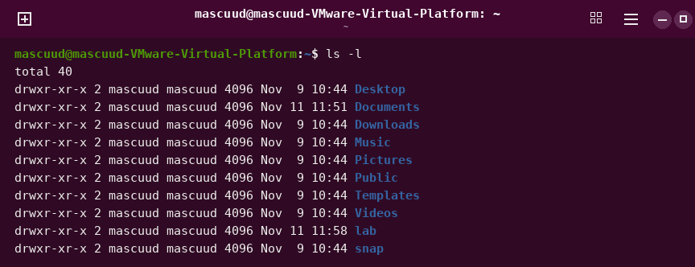
ls -lh / ls --human-readable
Shows file sizes in easy units like K and M.
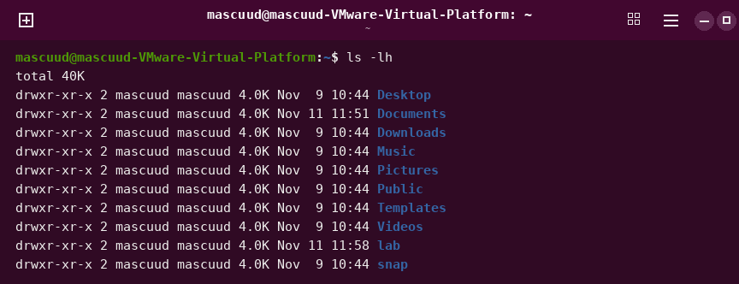
ls -la
Shows a long list with hidden files too.
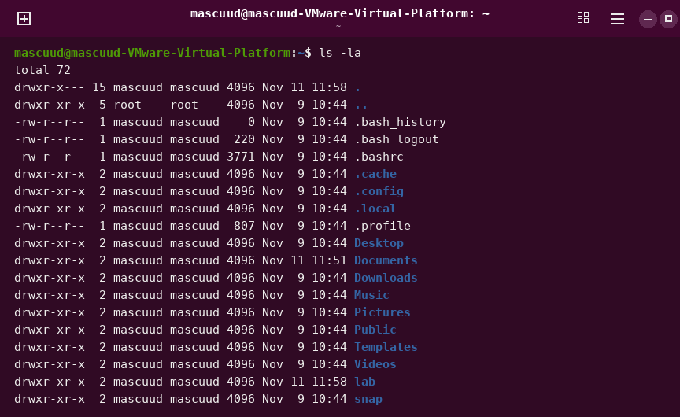
ls --all --format=long
Same as ls -la. These are the long option names.
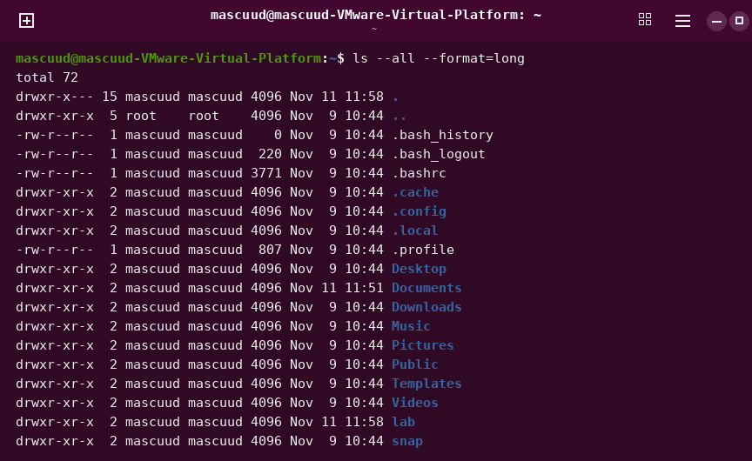
ls -a ~
Shows the hidden files in your home folder.
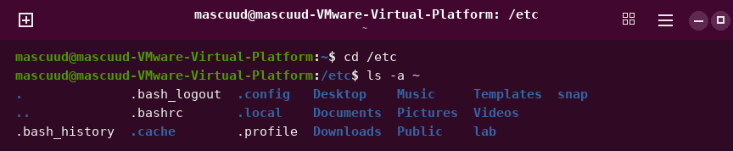
ls /sys/class/net
Lists the network cards of the computer.
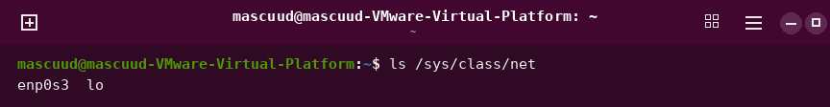
touch notes.txt todo.md
Makes two empty files.
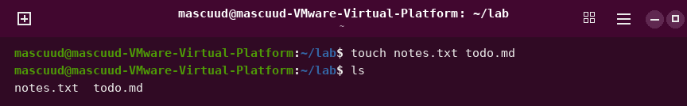
mkdir week3
Makes a new folder called week3.
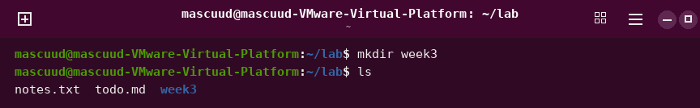
mkdir -p projects/linux
Makes a folder and the folder inside it.
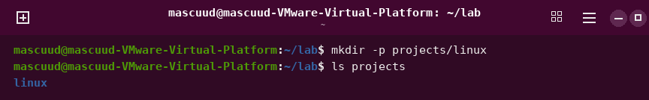
rmdir week3
Removes an empty folder.
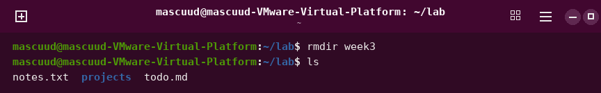
rmdir projects
Does not remove the folder, because it is not empty.
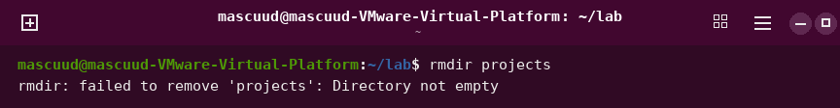
cp notes.txt notes.bak
Makes a copy of a file.
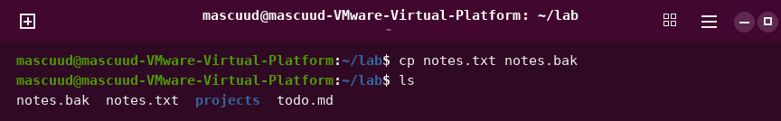
cp notes.txt backup/
Copies a file into a folder.
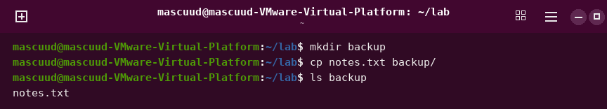
cp -r projects projects-copy
Copies a folder and everything inside it.
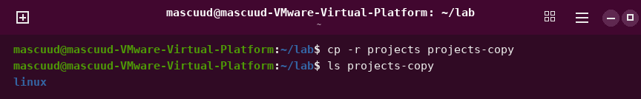
mv notes.txt old.txt
Changes the name of a file.
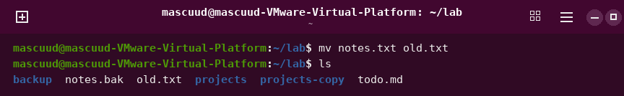
mv draft.txt final.txt
Changes the name of a file.
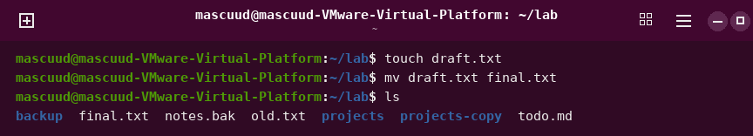
mv final.txt ~/Documents/
Moves a file into another folder.
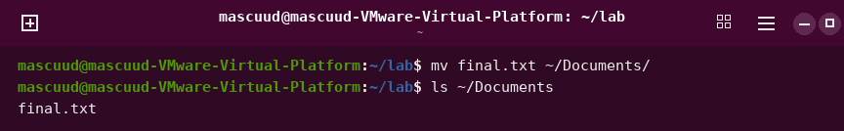
rm todo.md
Deletes a file. You cannot get it back.
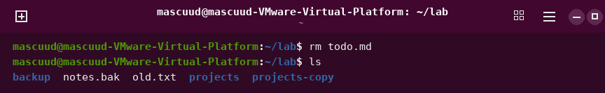
rm -i notes.bak
Asks you first, then deletes the file if you say yes.
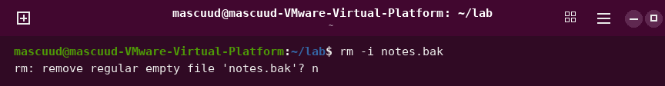
rm -r projects-copy
Deletes a folder and everything inside it.
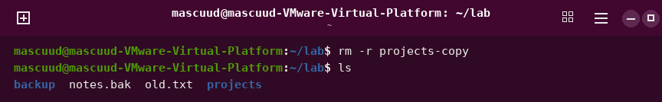
rm -rf folder
Deletes a folder at once, with no questions. Be careful.
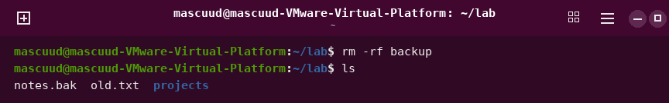

Chapter 3: Text Processing, Searching, Archiving, and Editors
mkdir -p ~/linux-ch3-lab
Makes the lab folder and goes into it.
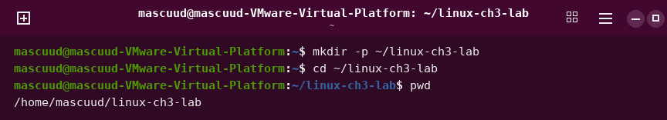
printf 'text\n' > file
Puts text into a file. This makes the sample files.
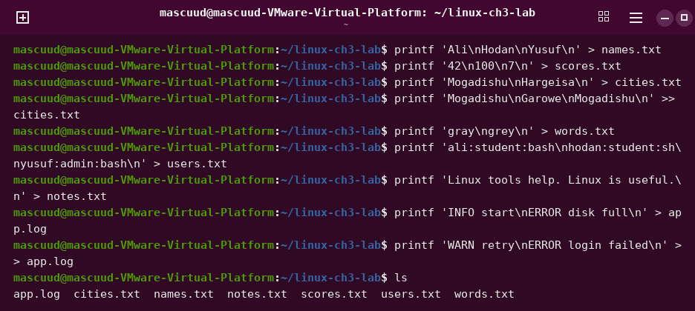
mkdir -p project/src and seq 1 60 > long.txt
Makes a folder inside a folder, and a file with the numbers 1 to 60.
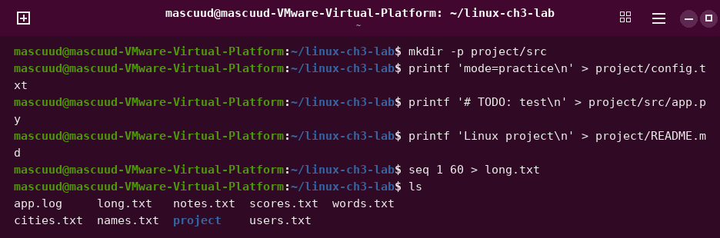
cat names.txt
Shows everything inside a file.
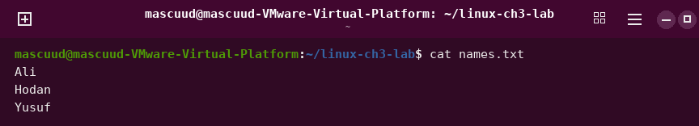
cat -n project/README.md
Shows the file with a number on each line.
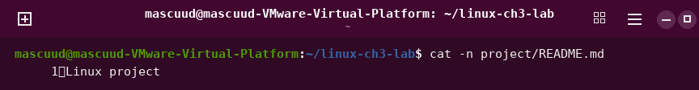
cat
Repeats every line you type. Press Ctrl+D to stop.
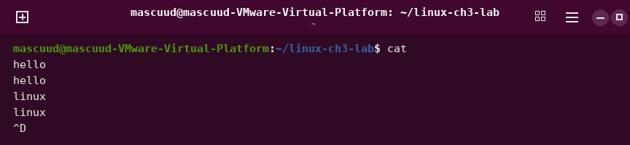
less long.txt
Shows a long file one page at a time. Press q to quit.
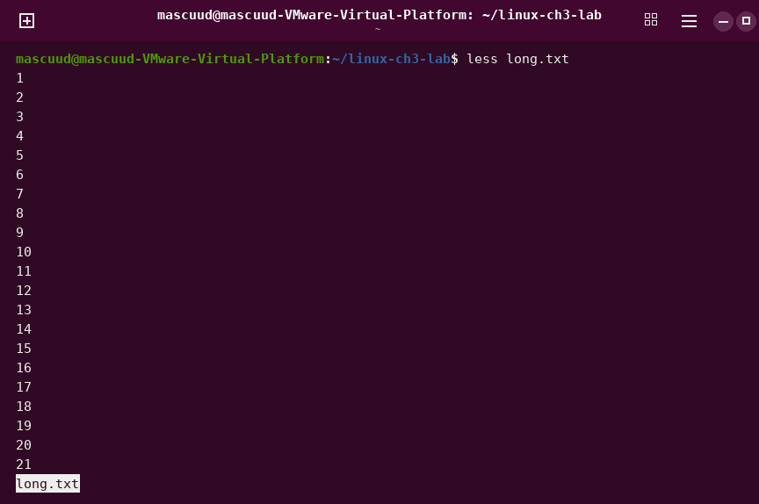
more long.txt
Shows a long file one page at a time. Press q to quit.
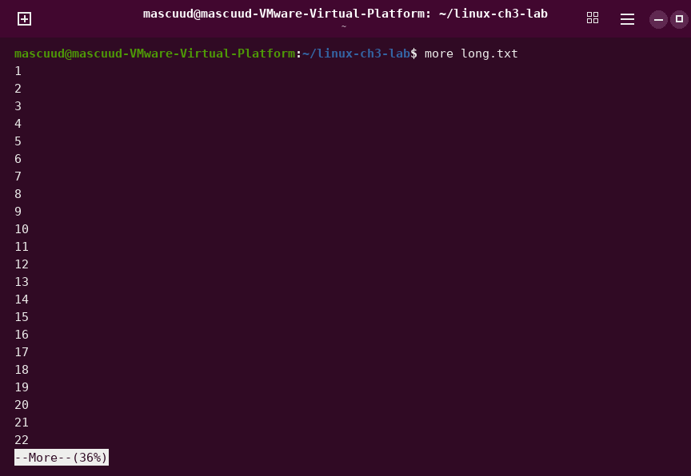
head -n 2 names.txt
Shows the first 2 lines of a file.
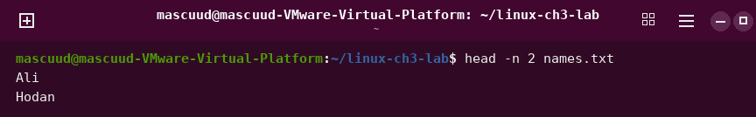
tail -n 2 names.txt
Shows the last 2 lines of a file.
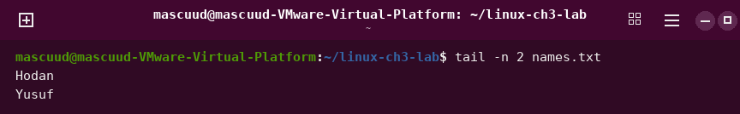
tail -n 2 -f app.log
Shows new lines at the end of a file as they come. Press Ctrl+C to stop.
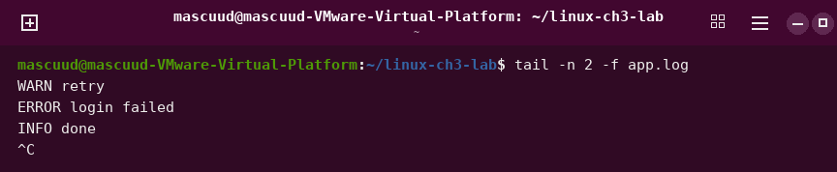
file names.txt
Tells you what type of file it is.
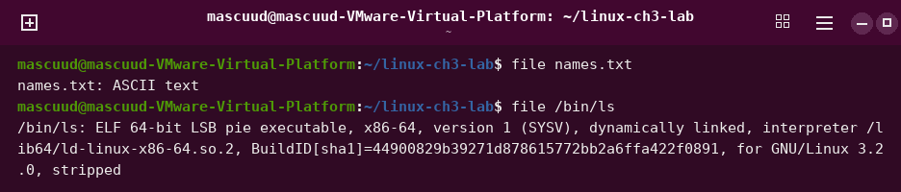
stat names.txt
Shows details about a file, like size and times.
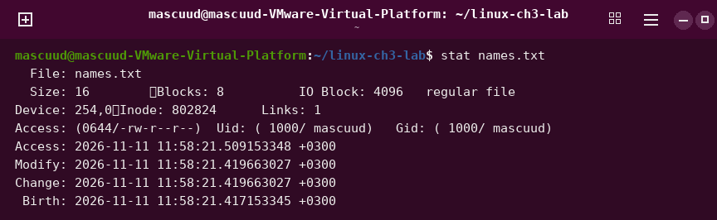
ls -l
Shows files with their rights, owner, size and date.
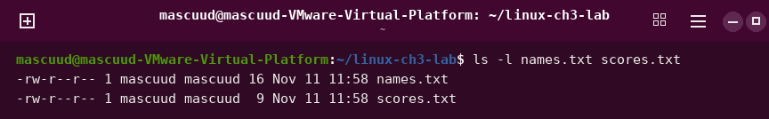
which ls
Shows where the program is.
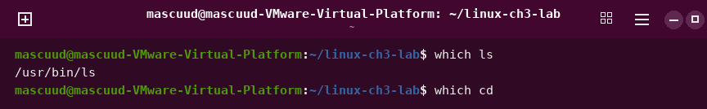
type cd
Tells you what kind of command this is.
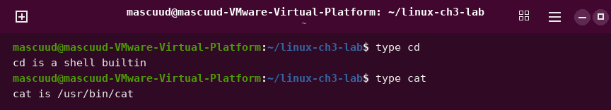
command -v ls
Shows where the command is.
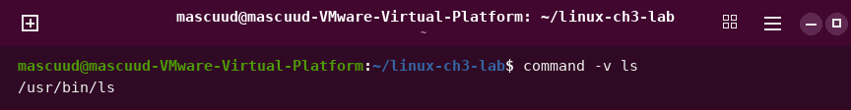
whereis tar
Shows where the program and its manual are.
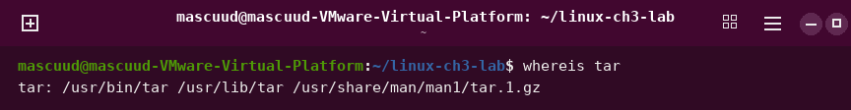
find . -name 'names.txt'
Looks for a file by its name.
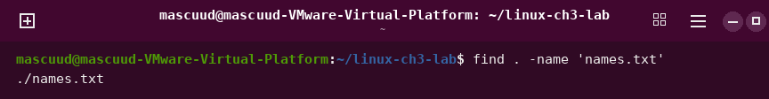
find . -name '*.log'
Looks for files that end with .log.
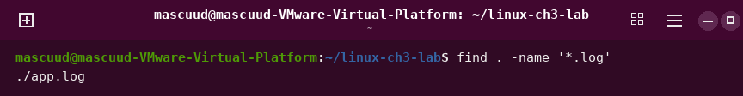
find . -name 'names.txt' -size +10c
Looks for a file by name that is bigger than 10 bytes.
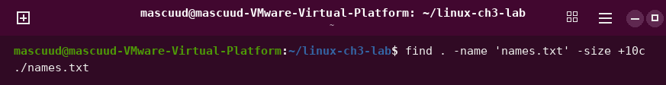
find . -type f -mmin -30
Looks for files that changed in the last 30 minutes.
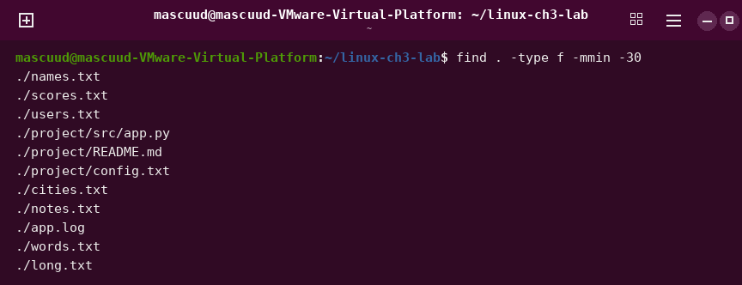
find project -type d
Looks for folders inside project.
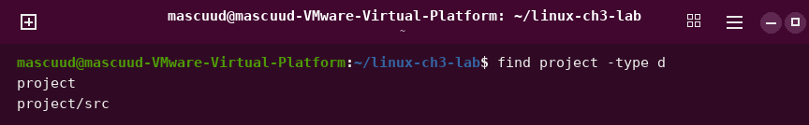
find project -name "*.py" -type f
Looks for .py files inside project.
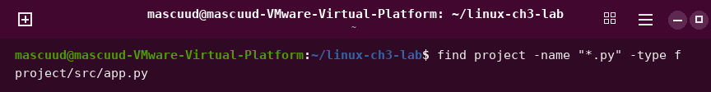
touch recent.txt and find . -name 'recent.txt'
Makes a new file, then finds it.
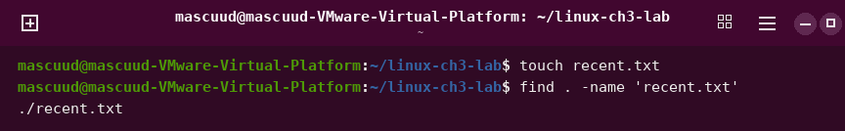
locate names.txt
Finds a file very fast by using a ready list.

locate recent.txt
May find nothing, because the ready list is old.

grep 'Ali' names.txt
Shows the lines that have the word Ali.
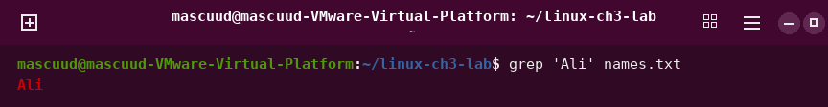
grep -i 'error' app.log
Shows lines with the word error. Big and small letters are the same.
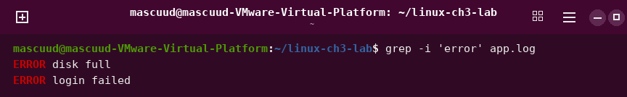
grep -n 'ERROR' app.log
Shows matching lines with their line numbers.
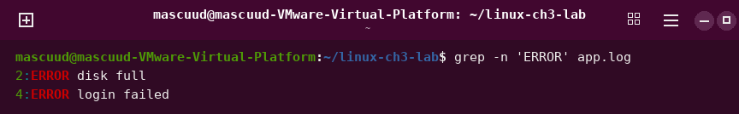
grep -in 'error' app.log
Shows matching lines with numbers. Big and small letters are the same.
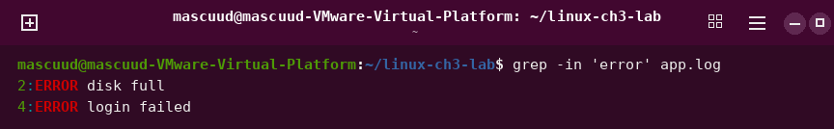
grep -v 'ERROR' app.log
Shows the lines that do not have the word.
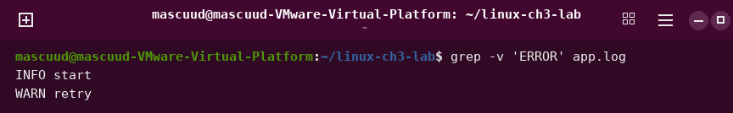
grep -rn 'TODO' project
Looks for the word in all files inside the folder.
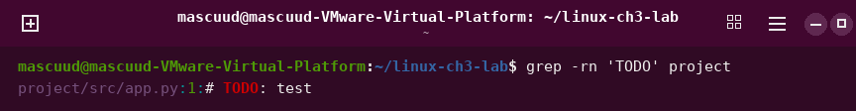
grep '^Ali' names.txt
Shows lines that start with Ali.
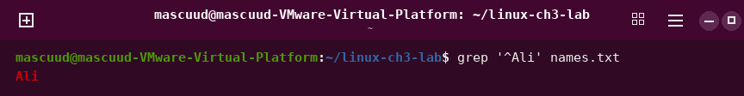
grep 'failed$' app.log
Shows lines that end with failed.
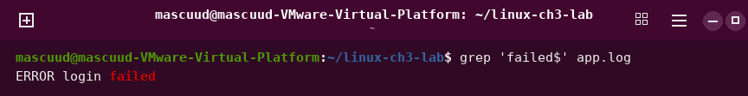
grep 'gr[ae]y' words.txt
Finds both gray and grey.
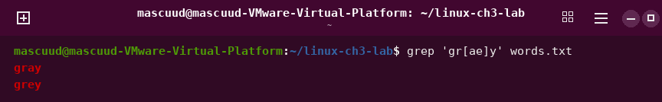
grep -i 'error' app.log | wc -l
Counts the lines that have the word error.
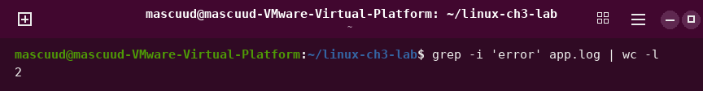
grep 'ERROR' app.log | wc -l
Counts the lines that have ERROR.
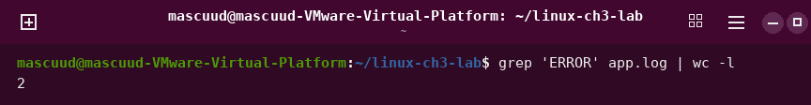
grep 'Mogadishu' cities.txt | wc -l
Counts the lines that have the word Mogadishu.
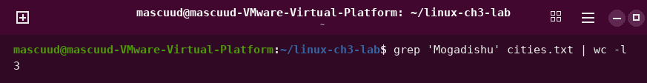
printf 'First\n' > actions.txt
Saves the word First in a file.
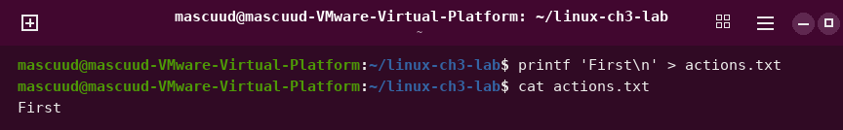
printf 'Second\n' >> actions.txt
Adds the word Second at the end of the file.
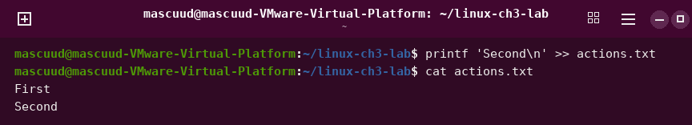
ls names.txt missing.txt
Shows the file name and an error for the missing file.
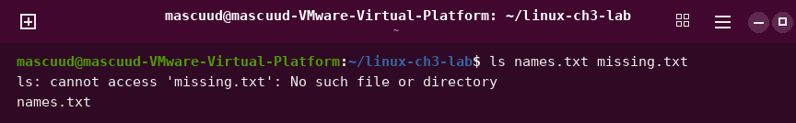
ls names.txt missing.txt > out.txt 2> err.txt
Saves the normal output in one file and the error in another file.
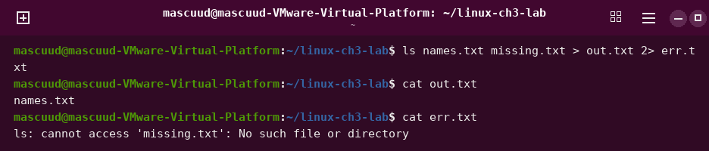
wc -l < names.txt
Counts the lines of a file by reading it as input.
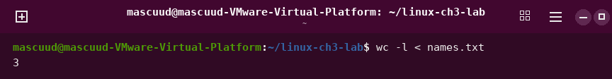
cat names.txt | wc -l
Counts the lines by sending the file through a pipe.
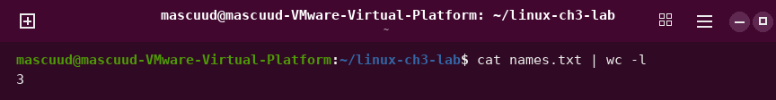
printf 'one\n'; printf 'two\n'
Runs two commands one after the other.
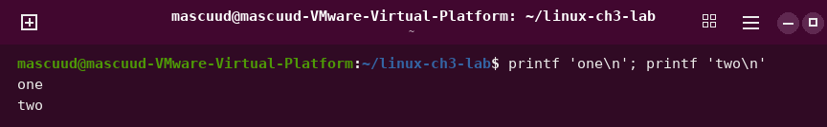
mkdir -p scratch && echo OK > scratch/status.txt
Makes a folder. Then, if it worked, it makes a file.
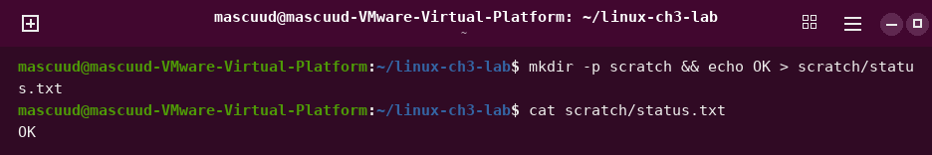
test -f missing.txt || echo 'Not found'
Prints Not found if the file does not exist.
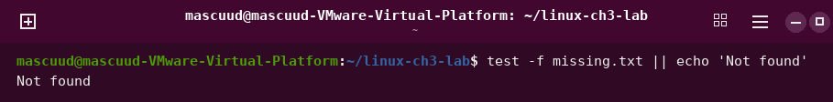
sort scores.txt
Puts the lines in order, like a dictionary.
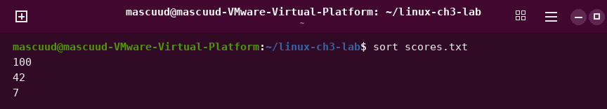
sort -n scores.txt
Puts numbers in order from small to big.
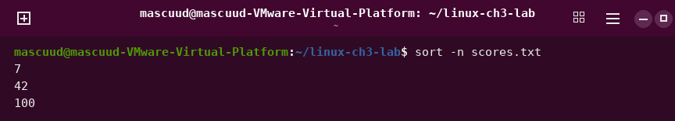
sort -rn scores.txt
Puts numbers in order from big to small.
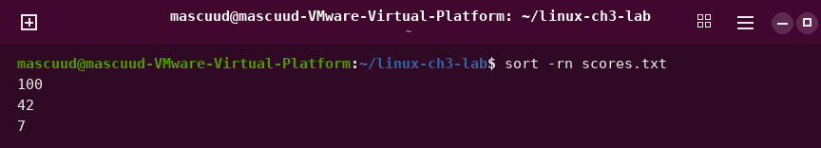
sort cities.txt | uniq
Removes lines that repeat.
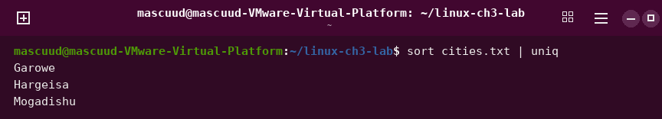
sort cities.txt | uniq -c
Counts how many times each line shows.
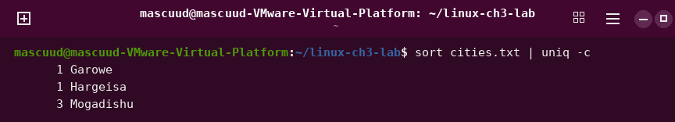
cut -d: -f1 users.txt
Shows the first part of each line. The parts are split by a colon.
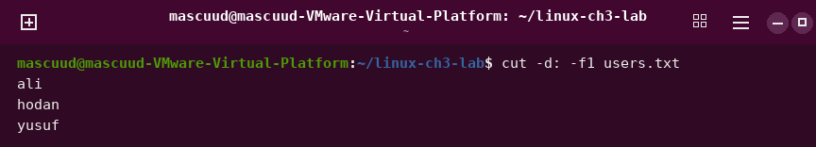
cut -d: -f 1,3 users.txt
Shows part 1 and part 3 of each line.
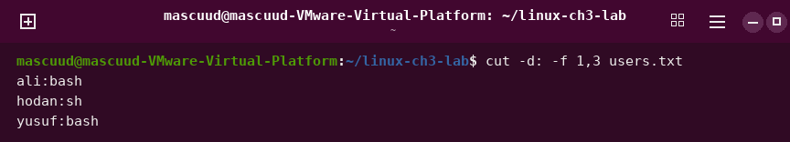
cut -d: -f3 users.txt | sort
Shows part 3 of each line, in order.
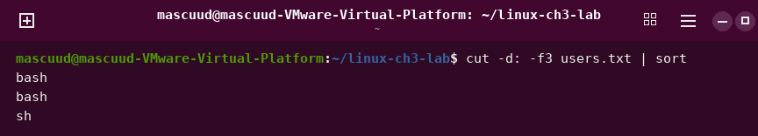
cut -d: -f3 users.txt | sort | uniq -c
Counts how many times each part 3 value shows.
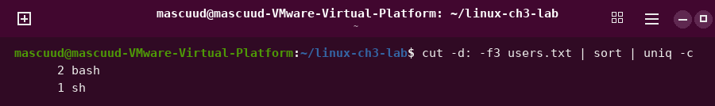
echo "somalia" | cut -c 1-4
Shows letters 1 to 4 of the word.
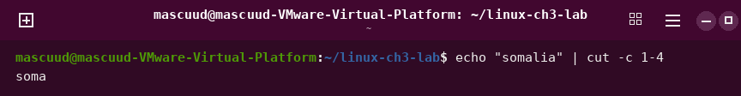
paste names.txt scores.txt
Puts two files side by side, line by line.
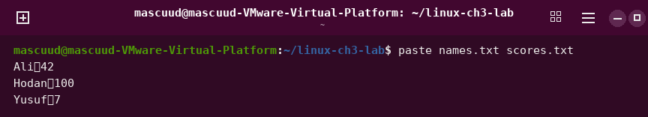
paste -d, names.txt scores.txt
Puts two files side by side with a comma between them.
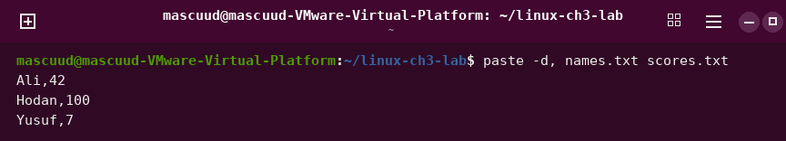
paste -s -d, names.txt
Puts all lines of a file on one line.
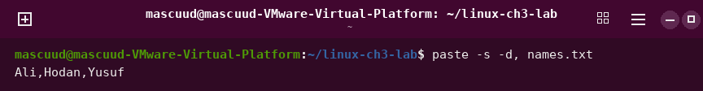
wc -l names.txt
Counts the lines in a file.
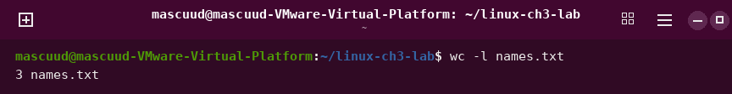
wc -w notes.txt
Counts the words in a file.
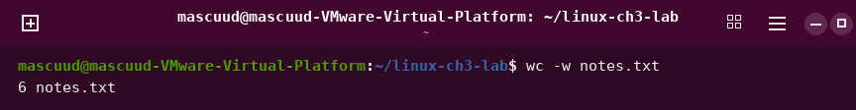
tr 'a-z' 'A-Z' < names.txt
Changes small letters to big letters.
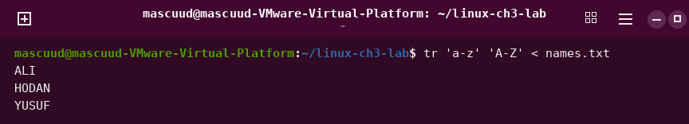
echo 'too many spaces' | tr -s ' '
Changes many spaces into one space.
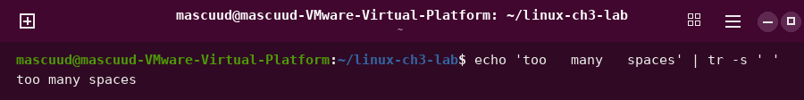
tr -cs '[:alpha:]' '\n' < notes.txt | tr '[:upper:]' '[:lower:]' | sort | uniq -c | sort -nr | head -n 1
Finds the word that shows most in a file.
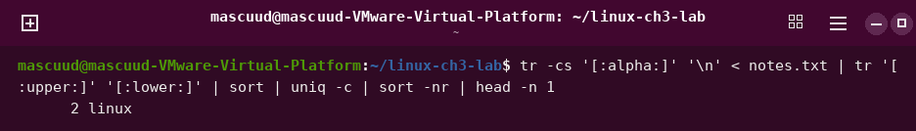
tar -cvf project.tar project/
Puts a folder into one file called an archive.
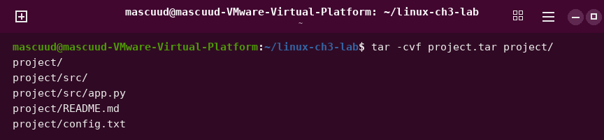
tar -cf notes.tar notes.txt words.txt
Puts two files into one archive.
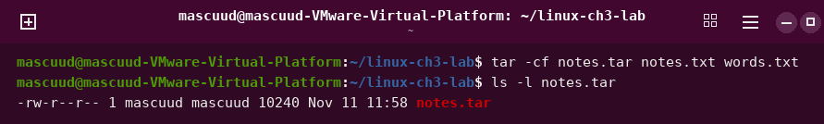
tar -tf project.tar
Shows what is inside an archive.
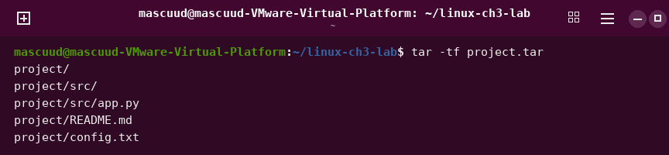
tar -xf project.tar -C restored-tar
Opens an archive into a folder.
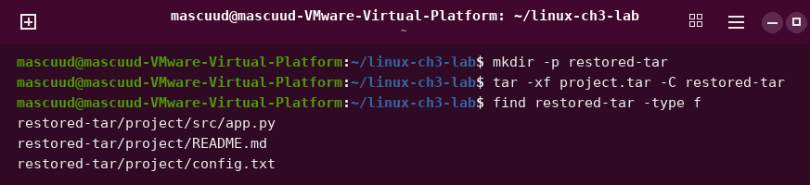
tar -czf project.tar.gz project/
Makes an archive and makes it smaller with gzip.
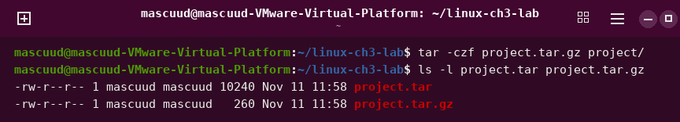
tar -tzf project.tar.gz
Shows what is inside a gzip archive.
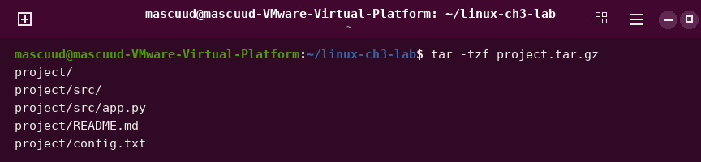
tar -cjf project.tar.bz2 project/
Makes an archive and makes it smaller with bzip2.
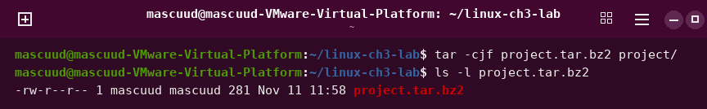
tar -cJf project.tar.xz project/
Makes an archive and makes it smaller with xz.
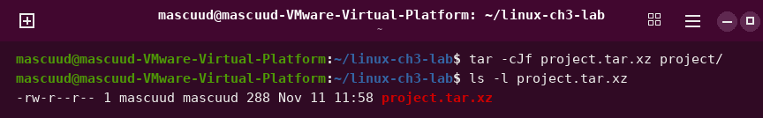
gzip -k -9 notes.txt
Makes a file smaller with gzip. It keeps the old file.
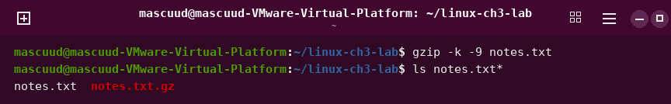
gunzip -c notes.txt.gz
Shows the text inside a .gz file.
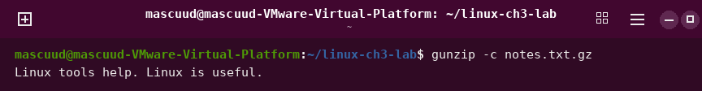
bzip2 -k app.log
Makes a file smaller with bzip2. It keeps the old file.
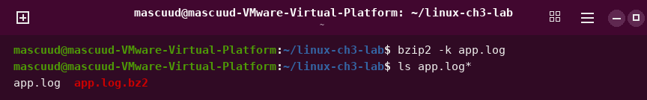
bzcat app.log.bz2 | head -n 1
Shows the text inside a .bz2 file. We show only the first line.
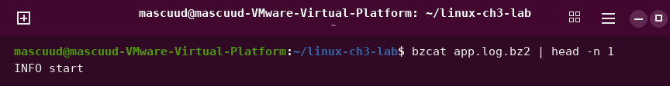
xz -k app.log
Makes a file smaller with xz. It keeps the old file.
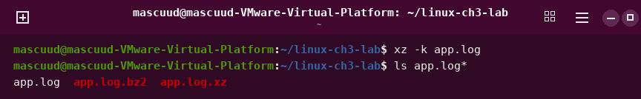
xzcat app.log.xz | head -n 1
Shows the text inside an .xz file. We show only the first line.
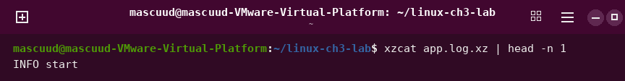
zip -r project.zip project/
Puts a folder into a zip file.
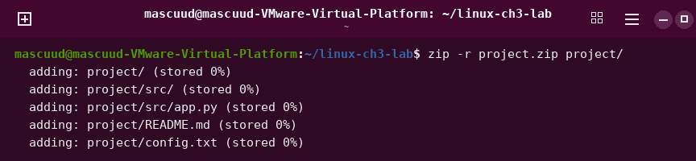
unzip -l project.zip
Shows what is inside a zip file.
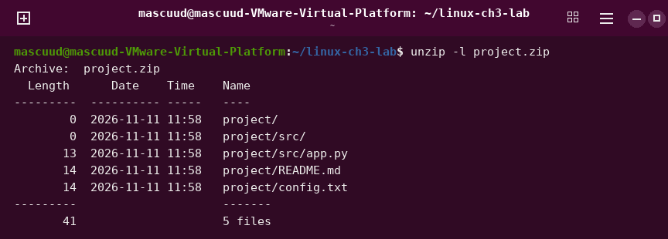
unzip project.zip -d restored-zip
Opens a zip file into a folder.
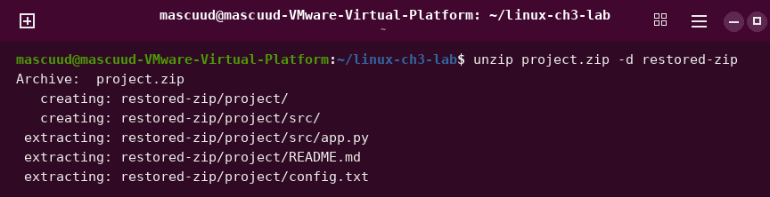
nano project/README.md
Opens a simple editor. Press Ctrl+O to save and Ctrl+X to exit.
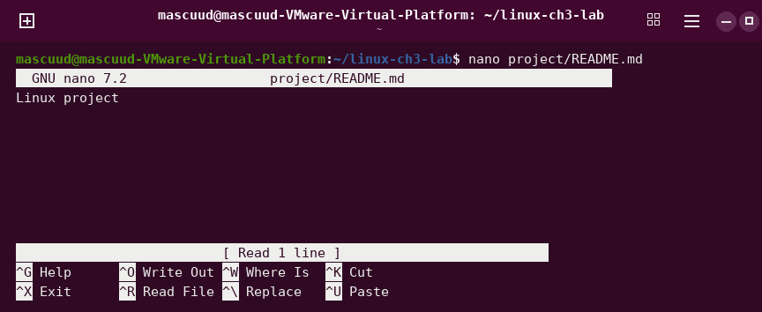
vim hello.txt
Opens a file in the Vim editor.
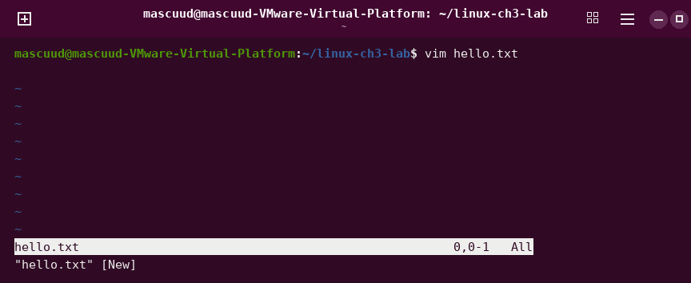
vim hello.txt
Press i to type text in Vim.
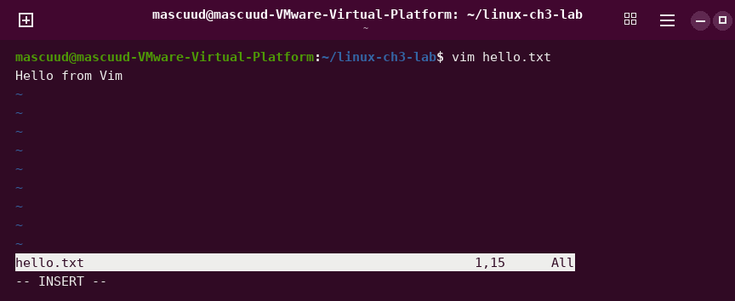
vi hello.txt
Opens a file in the vi editor. It works like Vim.
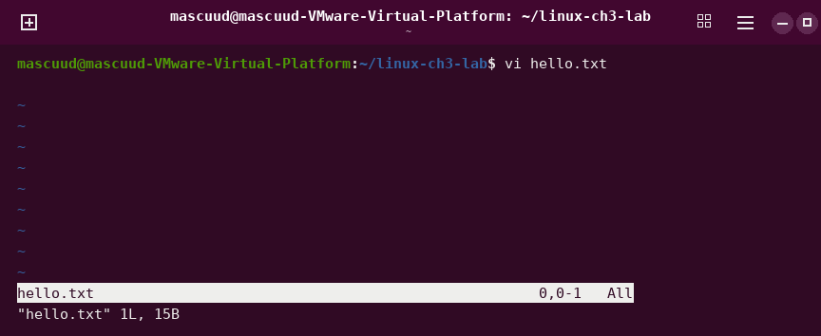
vim vim-practice.txt
Opens a practice file in Vim.
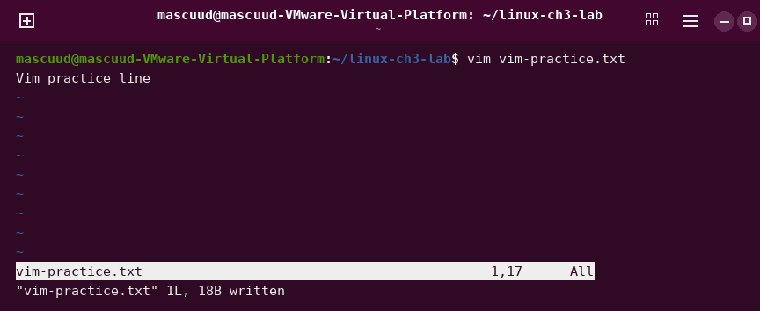
cat vim-practice.txt
Shows the text you saved.
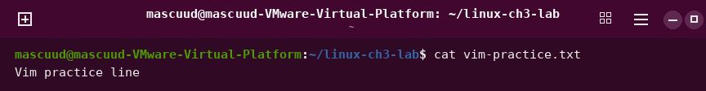
vim project/config.txt
Opens a file in Vim. Type :q! to leave without saving.
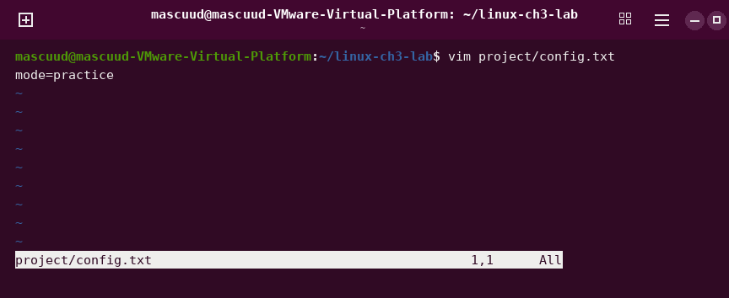
vimtutor
Opens a lesson to learn Vim.
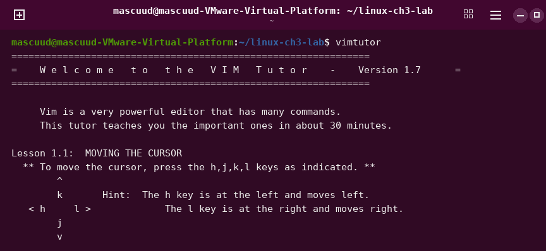
cp notes.txt link-source.txt
Makes a copy of a file to use for links.
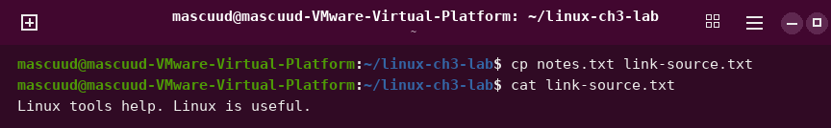
ln link-source.txt link-hard.txt
Makes a hard link. It is a second name for the same file.
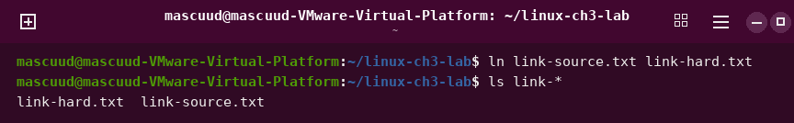
ls -li link-source.txt link-hard.txt
Shows the inode numbers. A hard link has the same number.
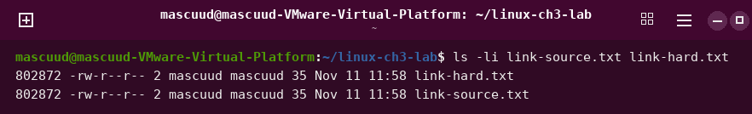
echo "added" >> link-hard.txt
Adds a line to the file. Both names show it.
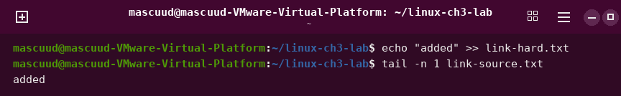
ln -s link-source.txt link-shortcut.txt
Makes a symbolic link. It is like a shortcut.
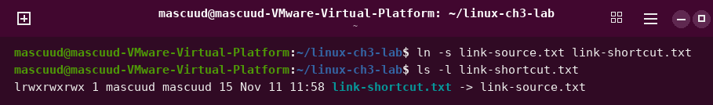
cat link-shortcut.txt
Shows the file that the shortcut points to.
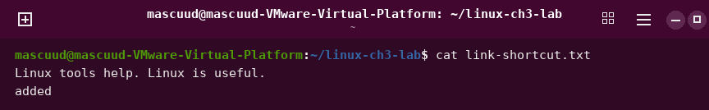
mv link-source.txt link-renamed.txt
Renames the file. The shortcut stops working.
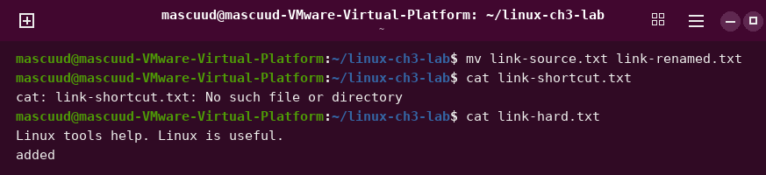

Chapter 4: Process, Service, and System Management
echo $$
Shows the process number of your shell.
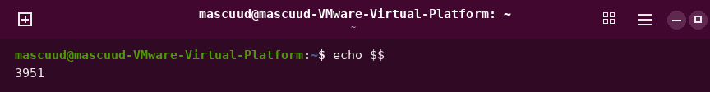
ps
Shows the processes in your terminal.
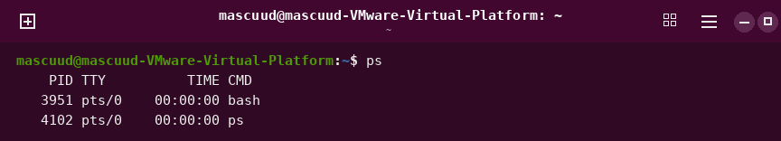
ps -o pid,ppid,comm
Shows the process number, the parent number and the name.
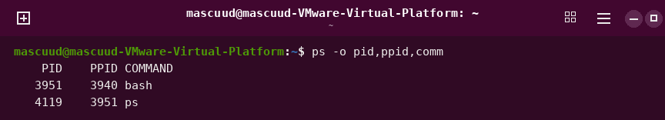
ps -f
Shows a longer list of processes.
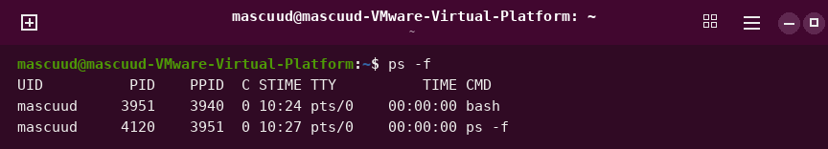
ps aux | less
Shows all processes, one page at a time.
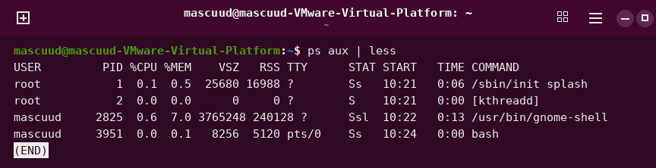
ps aux --sort=-%mem | head -n 5
Shows the 5 processes that use the most memory.
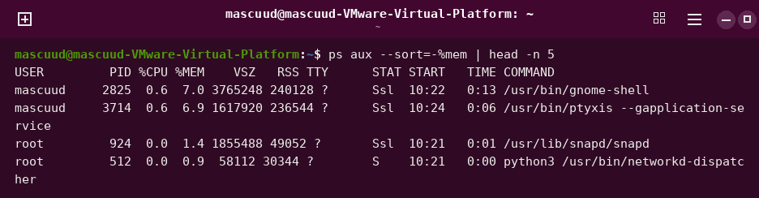
ps -ef | head -n 4
Shows the first 4 lines of all processes.
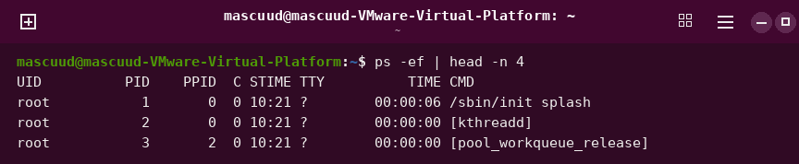
ps -ef | less
Shows all processes, one page at a time.
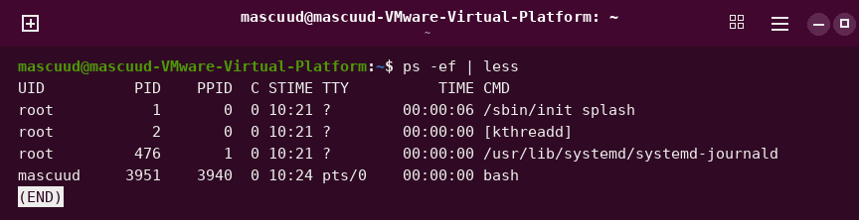
ps -p 1 -o pid,comm
Shows the process with number 1.
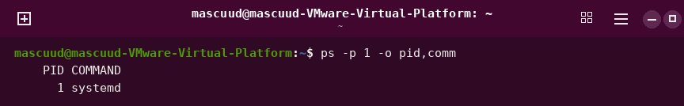
ps -p 1 -o pid,user,comm
Shows process 1 with its user.
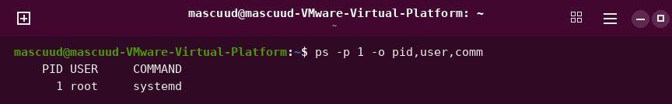
pstree -p $$
Shows the processes as a family tree.
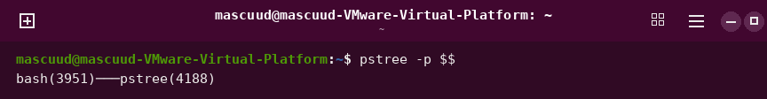
top
Shows live information about the processes. Press q to quit.
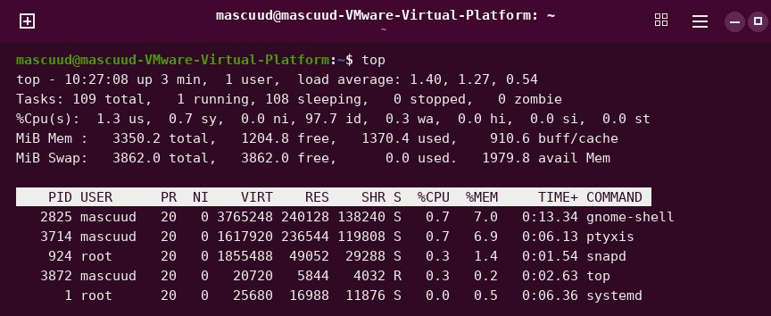
top -u mascuud
Shows live processes of one user only.
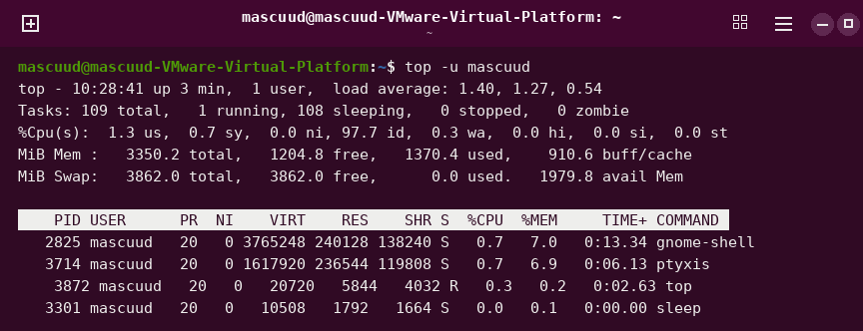
top -p 3301
Shows live information of one process only.
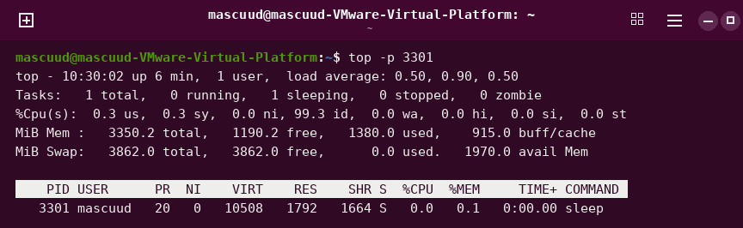
htop
Shows live processes with colors. It is easier than top.
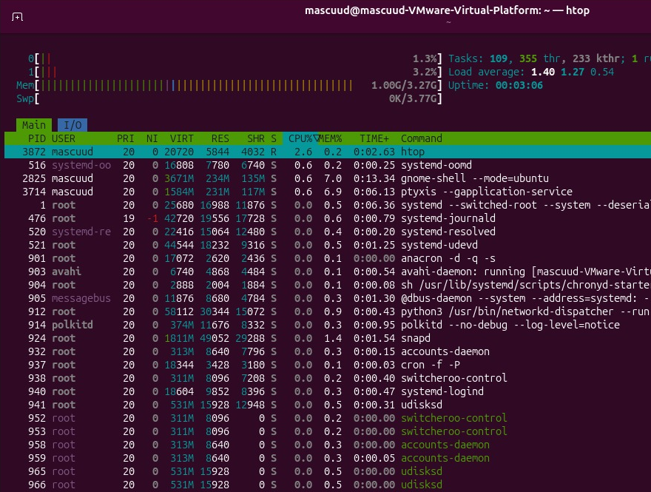
htop -u mascuud
Shows the live processes of one user.
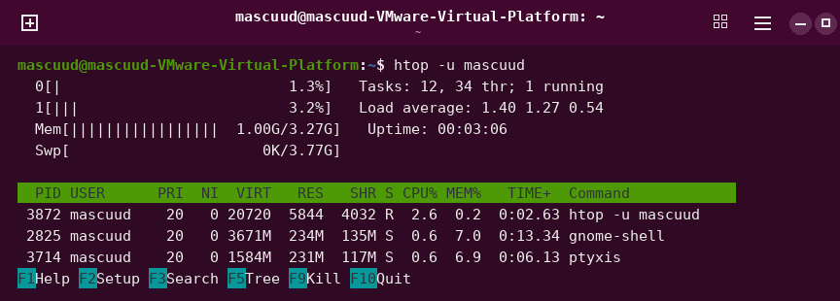
htop -t
Shows the processes as a tree.
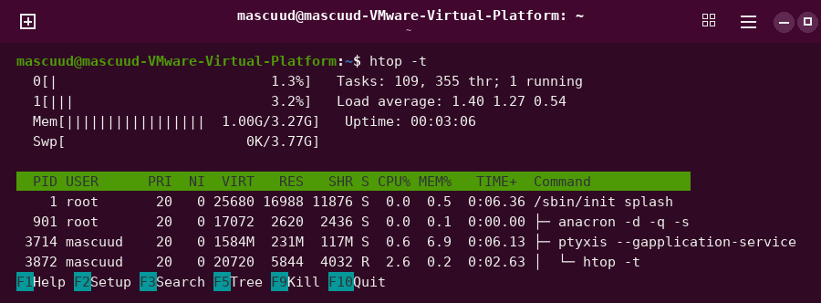
command -v htop
Shows where htop is. This tells you it is installed.
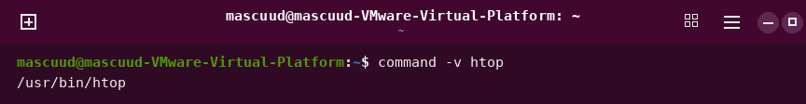
sleep 30
Waits for 30 seconds and does nothing.
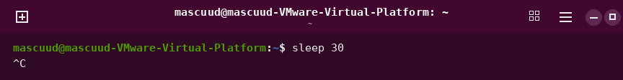
sleep 600 &
Runs sleep in the background. The terminal is free.
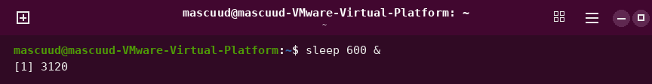
jobs
Shows the jobs in your shell.
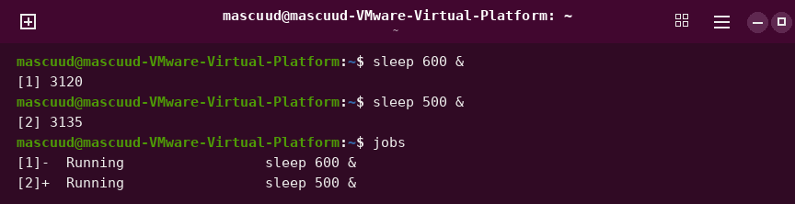
jobs -l
Shows the jobs with their process numbers.
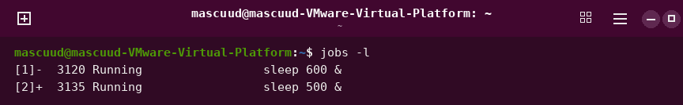
bg %1
Runs a stopped job in the background.
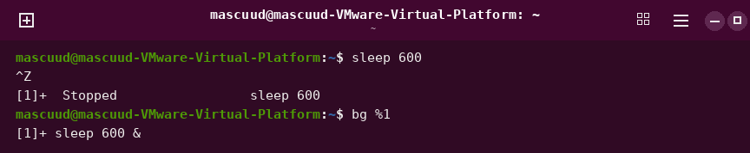
fg %2
Brings a background job to the front.
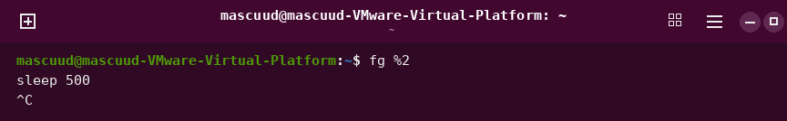
fg
Brings the last job to the front.
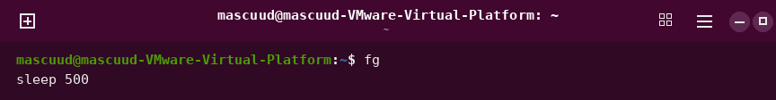
gnome-calculator &
Opens the calculator in the background.
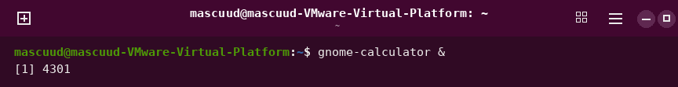
gnome-calculator
Opens the calculator. The terminal waits until you close it.

kill -l
Shows the list of signal names.
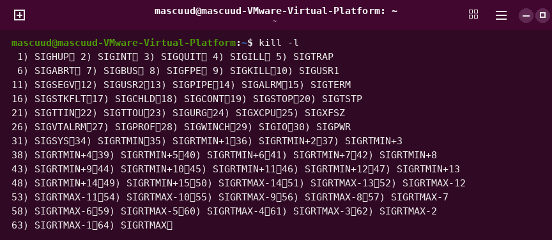
kill -l 15
Shows the name of signal 15.

kill 3120
Asks a process to stop.
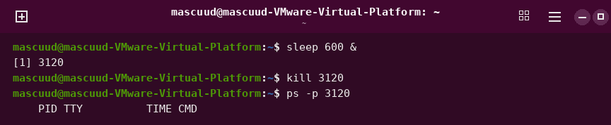
kill -TERM 2612
Asks a process to stop, using the signal name.

kill -9 2650
Forces a process to stop.
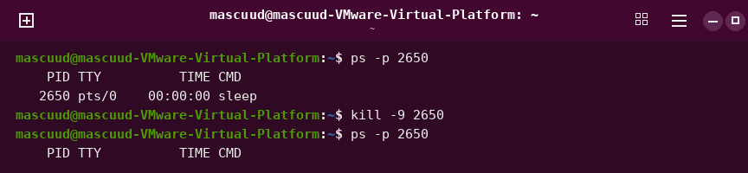
kill 2650 and kill 2610
Stops two processes by their numbers.
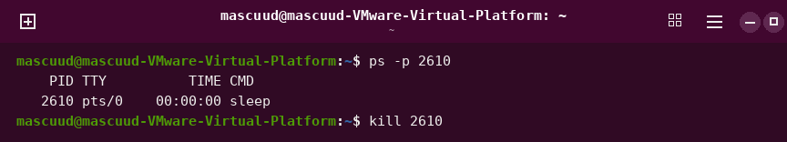
kill %1
Stops a job by its job number.
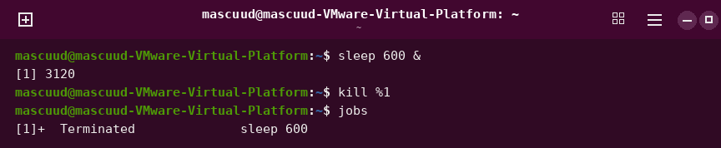
ps -p 3120 -o pid,ppid,stat,cmd
Shows details of one process.
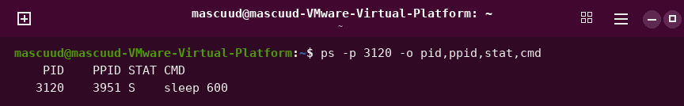
ps -p 3120
Shows if a process is still running.
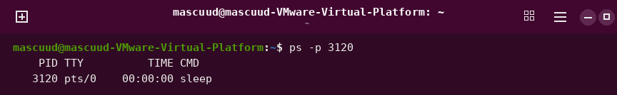
sudo kill -HUP 905
Asks a service to read its settings again.
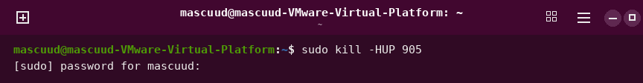
pgrep -a sleep
Finds processes by name.
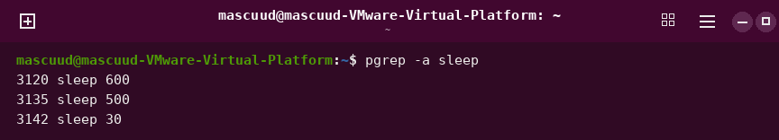
pkill -u mascuud sleep
Stops processes by name.

killall sleep
Stops all processes with this name.

nice
Shows the nice number of your shell.
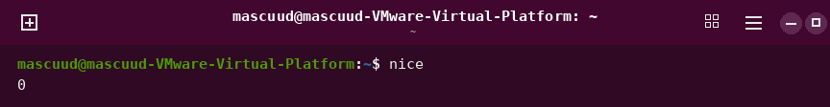
nice -n 10 sleep 300 &
Starts a program with a lower priority.
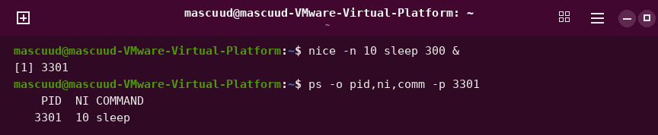
renice -n 5 -p 3301
Changes the priority of a running process.
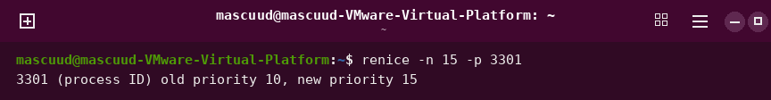
sudo renice -n 5 -p 3301
Changes the priority with admin rights.
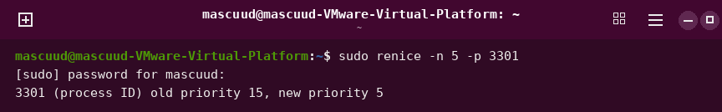
ps -o pid,ni,comm -p 3301
Shows the nice number of a process.
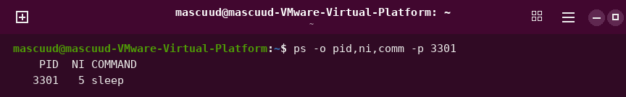
uname -a
Shows all system information.
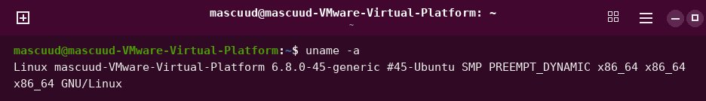
uname -r
Shows the kernel version.
uname -n
Shows the name of the computer.
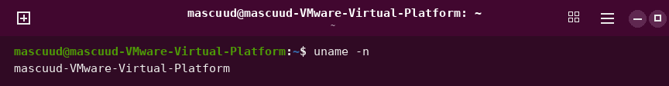
uname -m
Shows the type of computer hardware.
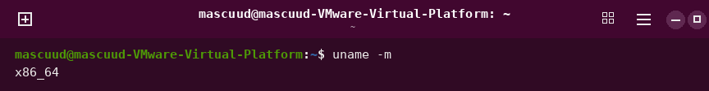
hostnamectl
Shows the computer name and system details.
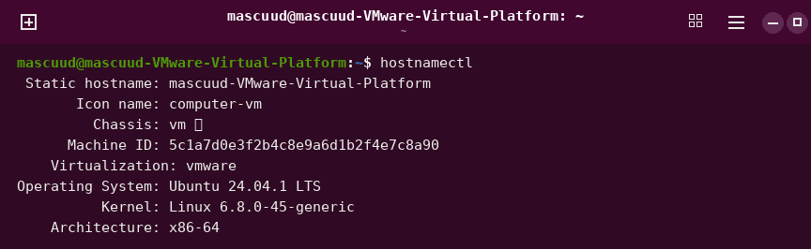
hostnamectl hostname
Shows only the computer name.
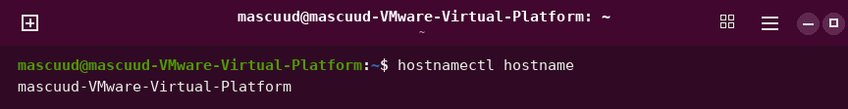
uptime
Shows how long the computer has been on.
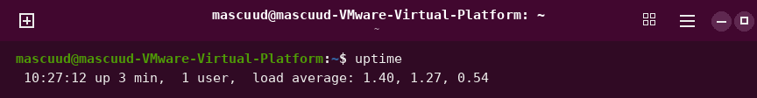
uptime -p
Shows the uptime in easy words.
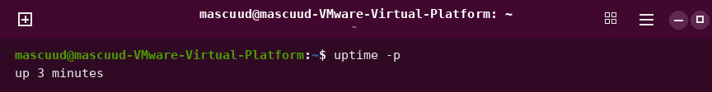
uptime -s
Shows the time when the computer started.
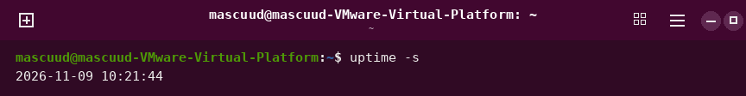
cat /proc/uptime
Shows the uptime in seconds.
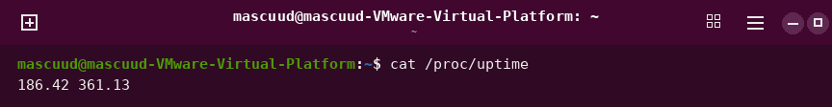
cat /proc/loadavg
Shows how busy the computer is.
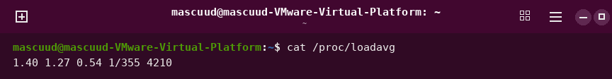
free -h
Shows memory use in easy units.
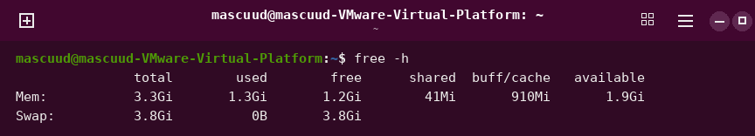
free -m
Shows memory use in megabytes.
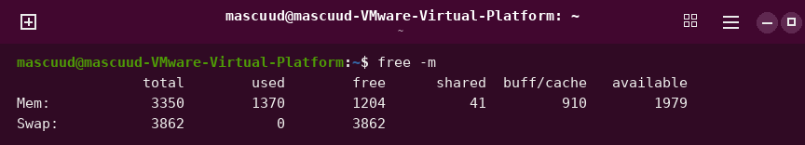
free -h -s 2
Shows memory use again every 2 seconds.
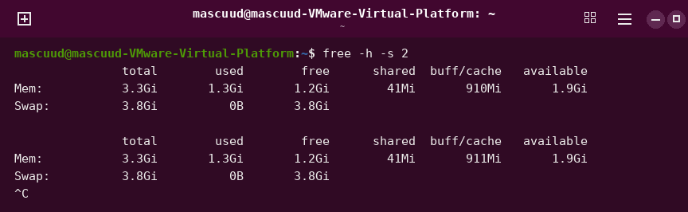
head -n 3 /proc/meminfo
Shows the first lines of the memory file.
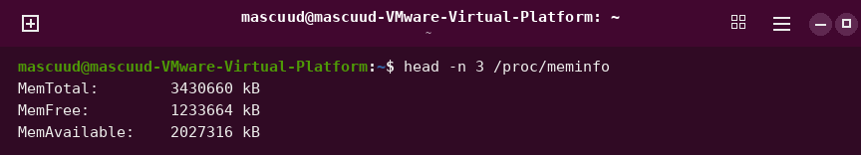
ls -l /proc/meminfo
Shows that the memory file has size 0.
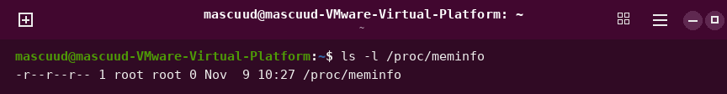
nproc
Shows how many CPUs the computer has.
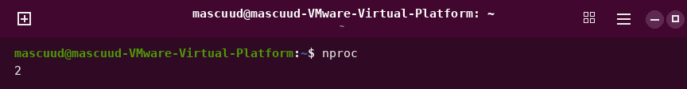
grep -c ^processor /proc/cpuinfo
Counts the CPUs.
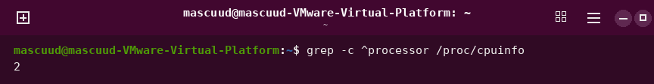
grep -m 1 "model name" /proc/cpuinfo
Shows the name of the CPU.
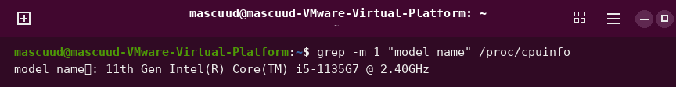
lscpu
Shows details about the CPU.
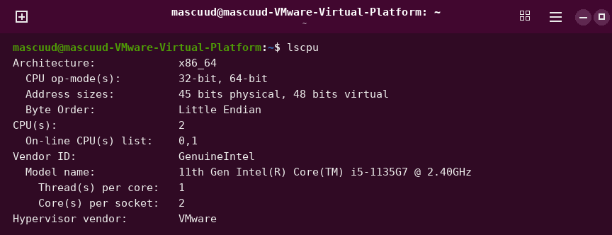
lscpu | less
Shows CPU details, one page at a time.
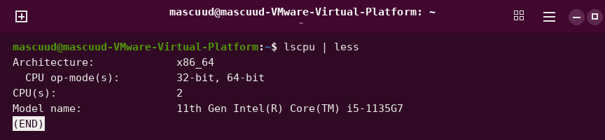
lsblk -e 7
Shows the disks and partitions.
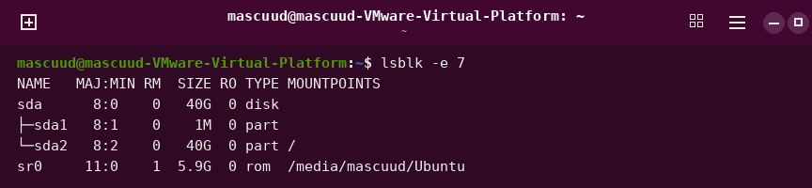
lsblk -e 7 -d -o NAME,SIZE,MODEL
Shows only the disks.
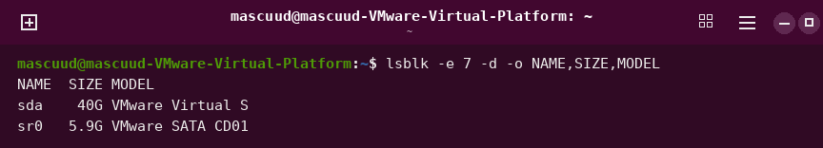
ls /proc
Shows the files in /proc.
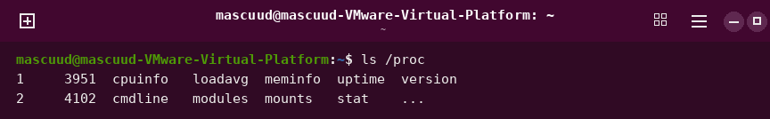
ls /proc/$$
Shows the files of your shell process.
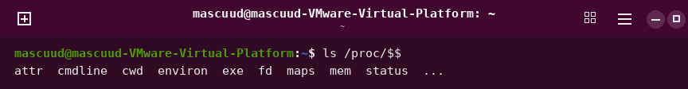
cat /proc/1/comm
Shows the name of process 1.
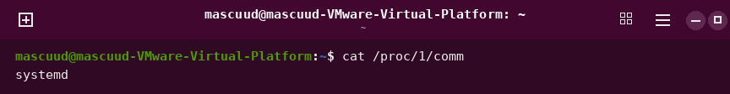
head -n 7 /proc/$$/status
Shows the status of your shell.
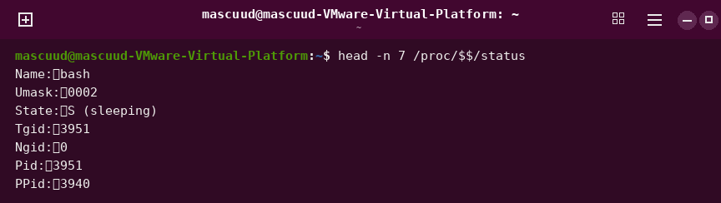
ls /sys
Shows the folders in /sys.
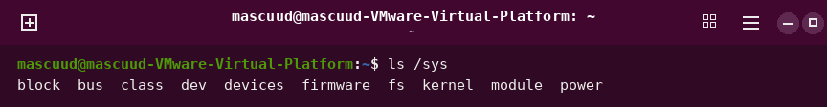
ls /sys/block
Shows the disks the kernel knows.
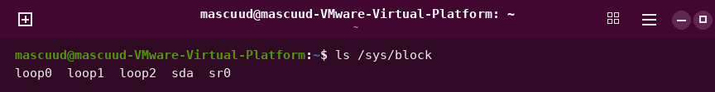
cat /sys/class/net/enp0s3/address
Shows the address of the network card.
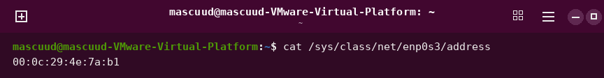
systemctl status cron
Shows if the cron service is running.
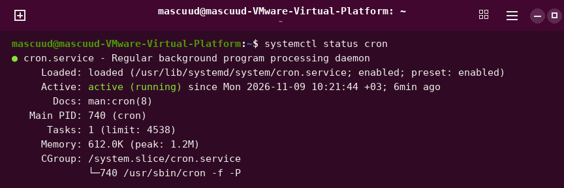
systemctl status ssh
Shows if the ssh service is running.
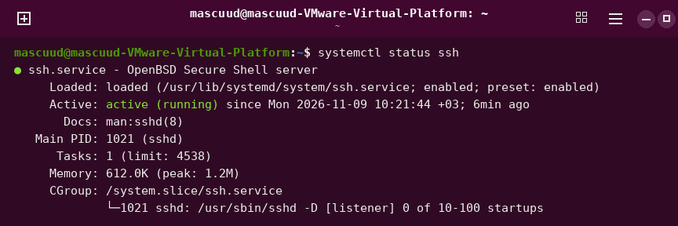
systemctl is-active cron
Shows if the service is active.
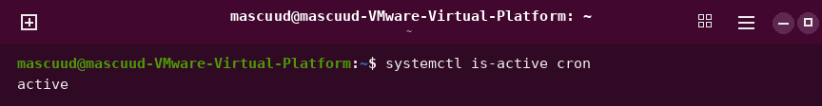
systemctl is-enabled cron
Shows if the service starts at boot.
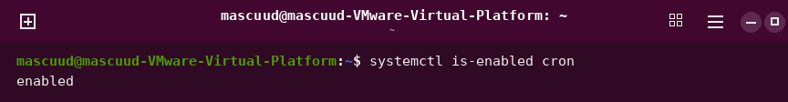
systemctl show -p MainPID cron
Shows the main process number of the service.
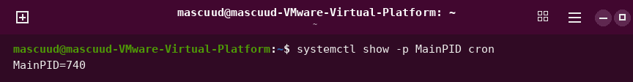
systemctl cat cron
Shows the file that starts the service.
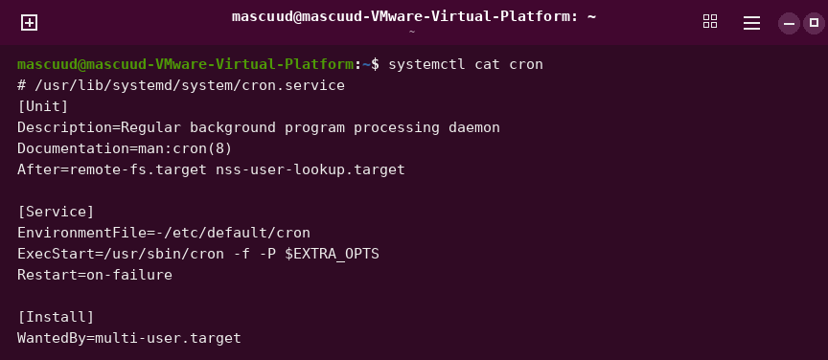
systemctl list-units --type=service --state=running
Lists the services that are running.
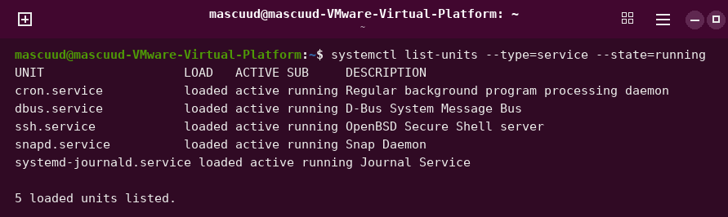
systemctl list-units --type=service --state=failed
Lists the services that failed.
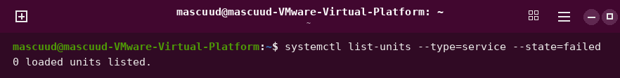
sudo systemctl stop cron
Stops the service now.
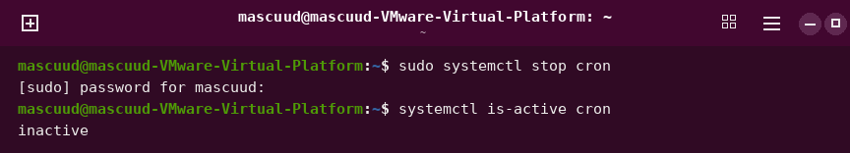
sudo systemctl start cron
Starts the service now.
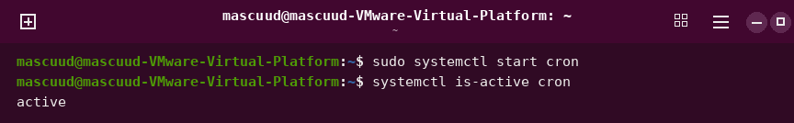
sudo systemctl restart cron
Stops the service and starts it again.
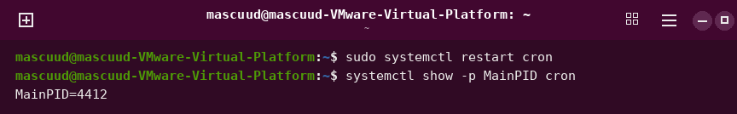
sudo systemctl reload cron
Makes the service read its settings again.
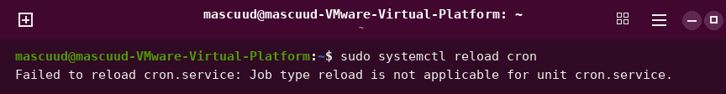
sudo systemctl reload ssh
Makes the ssh service read its settings again.

sudo systemctl reload-or-restart cron
Reloads the service, or restarts it if it cannot reload.

sudo systemctl disable cron
Stops the service from starting at boot.
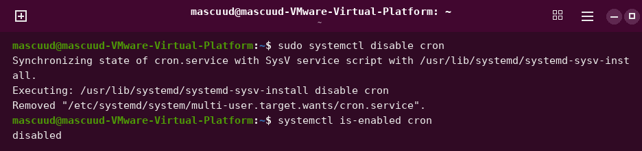
sudo systemctl enable --now cron
Starts the service at boot and now.
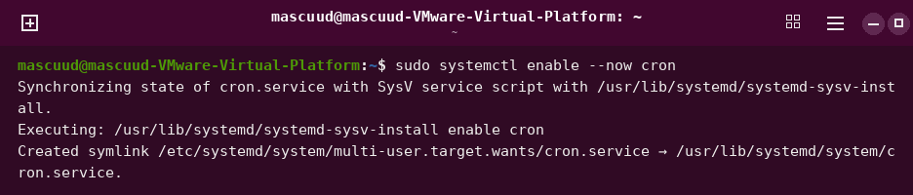
sudo sshd -t
Checks the ssh settings for mistakes.

ls /etc/ssh
Shows the ssh settings files.
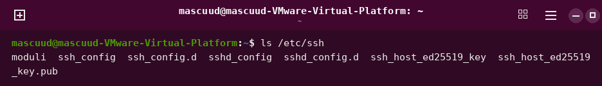
ls /var/log
Shows the folder with the log files.
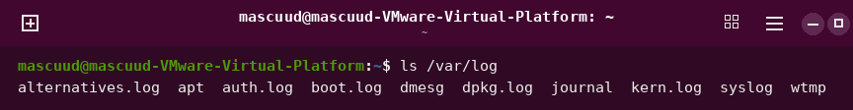
less /var/log/syslog
Shows the main log, one page at a time.
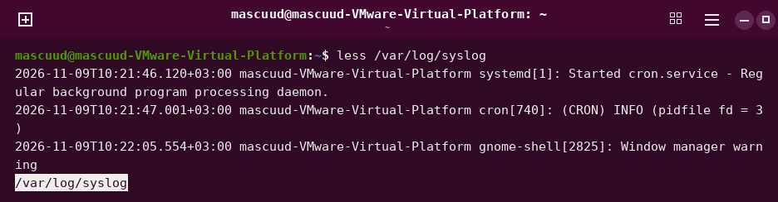
tail -f /var/log/syslog
Shows new log lines as they come. Press Ctrl+C to stop.
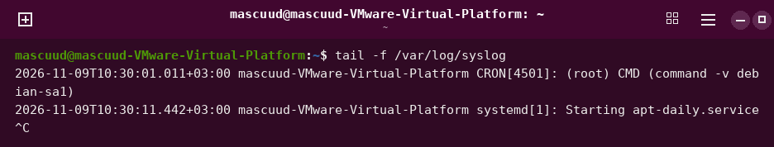
tail -n 3 /var/log/kern.log
Shows the last 3 lines of the kernel log.
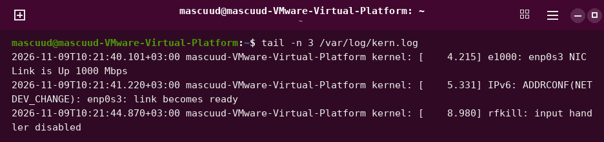
journalctl
Shows the system log.
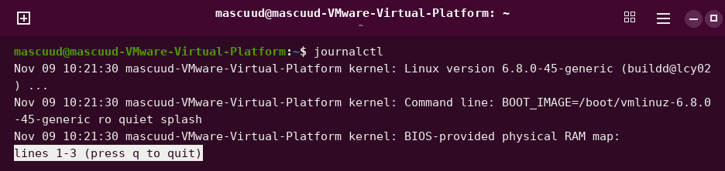
journalctl -n 3
Shows the last 3 lines of the log.
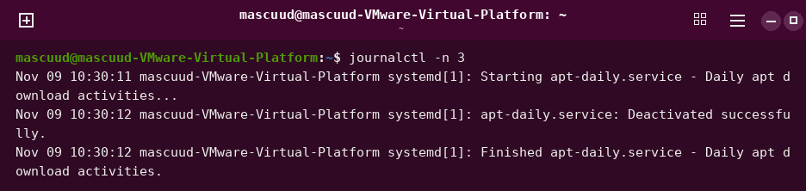
journalctl -b
Shows the log of this boot.
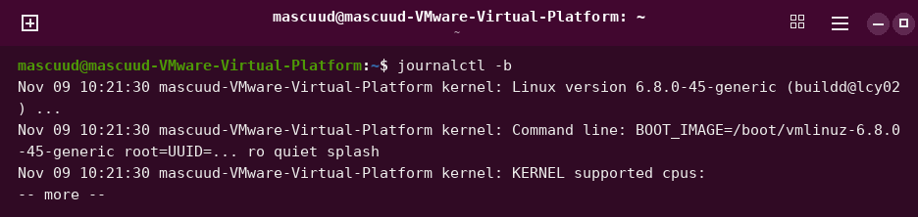
journalctl -b -p err
Shows only the errors of this boot.
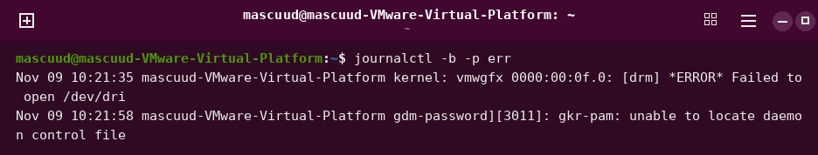
journalctl -u cron -n 4
Shows the last 4 log lines of the cron service.
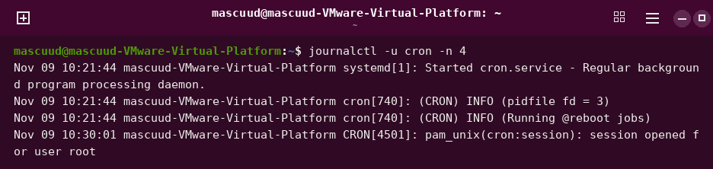
journalctl -u cron -f
Shows new log lines of the cron service.
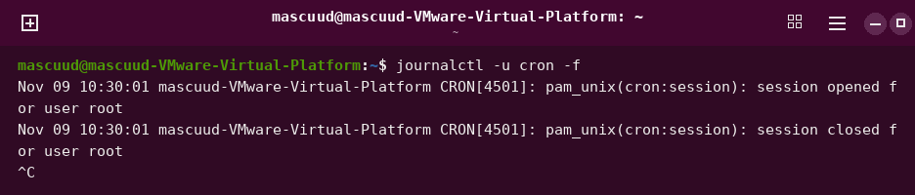
journalctl -u cron --since "1 hour ago"
Shows the cron log of the last hour.
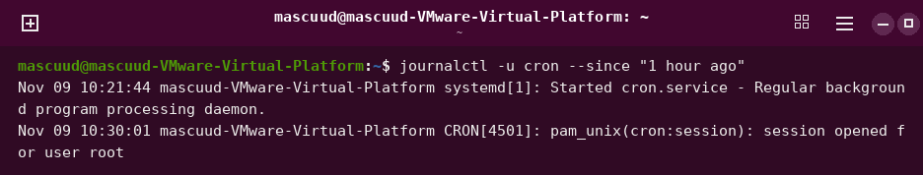
journalctl -u ssh -n 20
Shows the last 20 log lines of the ssh service.
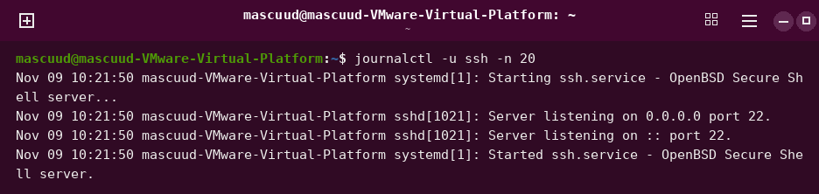
journalctl -u ssh -n 30
Shows the last 30 log lines of the ssh service.
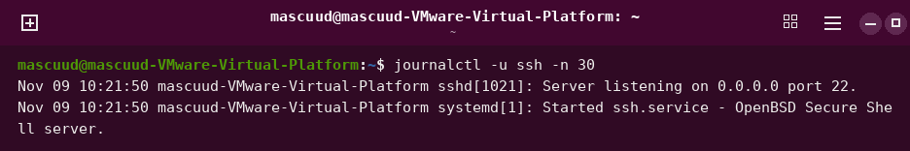
journalctl -f
Shows new log lines of the whole system.
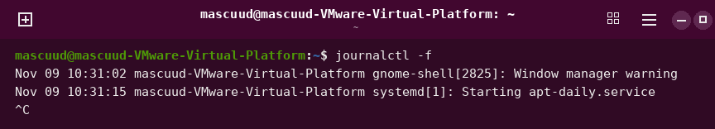
journalctl -xe
Shows the end of the log with help text.
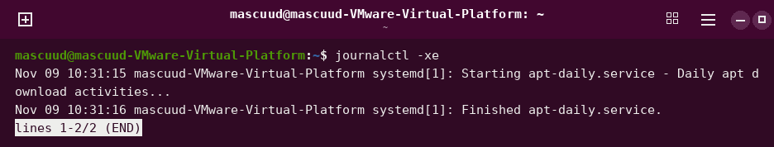
journalctl -k -b
Shows the kernel messages of this boot.
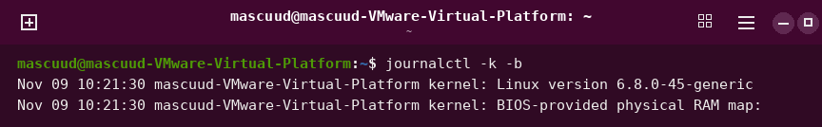
journalctl _COMM=sudo -n 1
Shows the last message from sudo.
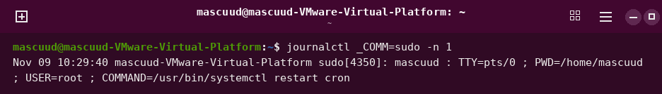
grep sudo /var/log/auth.log | tail -n 1
Shows the last sudo line in the login log.
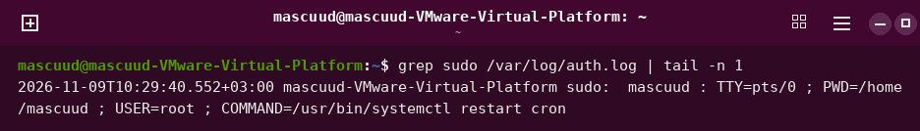
logger "week 8 test from student"
Writes your own message in the log.
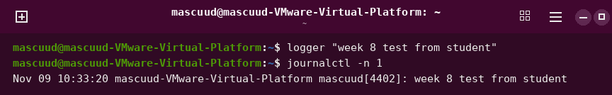
dmesg
Shows the kernel messages. You may need sudo.
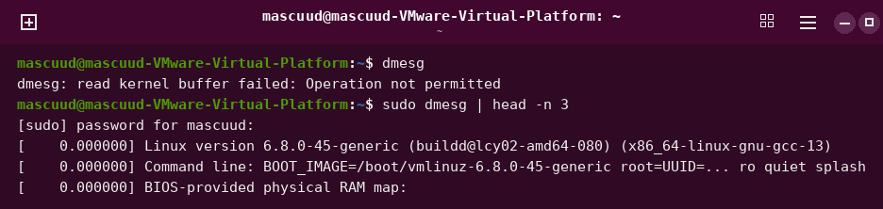
sudo dmesg | less
Shows the kernel messages, one page at a time.
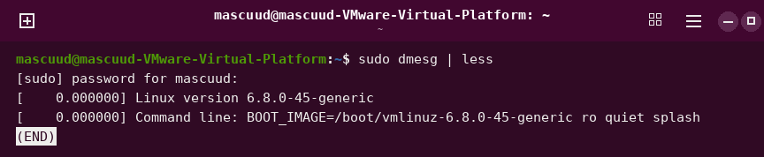
sudo dmesg -T | tail -n 2
Shows the kernel messages with real time.
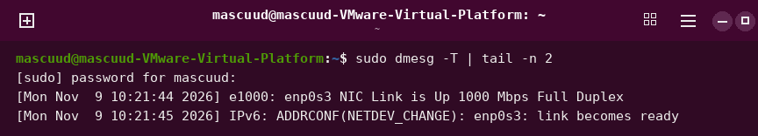
last -n 2
Shows the last 2 logins.
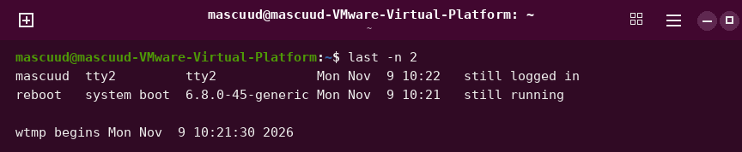
sudo shutdown -r +5 "Rebooting for the lab"
Restarts the computer after 5 minutes.
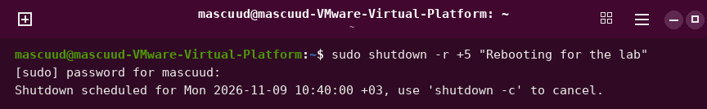
sudo shutdown -c
Cancels a planned shutdown.

sudo reboot
Restarts the computer now.
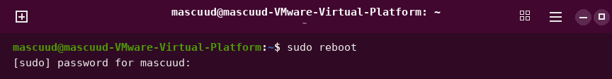
sudo poweroff
Turns off the computer now.


